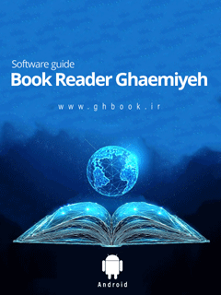

Guidebook for Gh-book Android App


ghaemiyeh.com

فهرست مطالب
Book ID 7
Download Gh-Book Application 7
Point 7
Ghaemiyeh Digital Library 7
Bazzar app store 7
Install Gh-Book App 8
Allow Unknown Sources 8
Installing the App 9
Running the app 12
Point 12
First Time Entering 13
Point 13
1-Pictorial Help of Gh-Book 14
2-Sign Up 15
Point 15
Using Google Account 15
Using non-google Email 19
Sign in as a Guest 20
Sign in 21
Password Recovery 22
Main Page 28
Point 28
1-Top Taskbar 28
2-Main Tabs 29
Introduction to the Software 29
1-Main menu 29
Point 29
1-Profile 30
2-General Search Tool 32
Point 32
Explanation of icons in search page 37
Point 37
Searching as the word written 40
Point 40
Multi-Words 42
Point 42
1-All words without order 42
2-All words with order 42
3-At least one of the words 42
Order of Results 43
Point 43
Page Number 43
Degree of similarity 43
Search Window 44
3-Notes list and annotations 46
Point 46
Highlights 47
Favorites 48
Explanation of Icons 49
4-Download management 52
5-Update 56
6-Help 59
7-General Setting 59
Point 59
Language Setting 61
Text Display Setting 62
Point 62
1-Keep the screen on 62
2-Selection Text Defaults 63
3-Address Setting in Sharing 65
Book Display Settings 67
Point 67
1-Page number view 67
2-Layout by actual pages: 68
3-Select text with double tap 69
Taking Note Settings 69
1-Opening Notes 69
2-Number of last selected note's subject 70
General Setting 71
Use SD Card 71
Delete Network Library 72
Saving Highlights, Favorites, and Comments(Data) 72
Recovery Comments, Highlights, and Favorites(Data) 76
8-Support 79
9-About Us 82
10-Last Changes 82
11-Inbox 82
12-Sync 83
13-Share App 83
2-Main tabs 84
Notes 84
Point 84
Notes Setting 85
Point 85
Editing 85
Delete 85
Share 85
Send Notes to categories 87
Adding Notes 89
Point 89
New Notes 90
The Category 94
Setting for category of Notes 95
1-Library 96
2-Favorites 97
3-My Books 99
Setting of books in Local Library 100
Point 100
1-Details 100
2-Add to Favorites 104
3-Share 104
4-Delete 105
Ordering Books and Notes 105
Point 105
By Last read 106
By user 106
By Download time 107
Views of Books 107
Inbox 108
Search in All Books 109
Reading book 113
Point 113
Reading Tools 115
Point 115
Setting of the page 116
Point 116
1-Font options 117
Point 117
Font name 117
Font Size 117
Margins 117
Line Spacing 117
Justify 118
Right to Left 118
Diacritic 118
Colored Diacritic 118
2-Display options 118
Point 118
Theme 119
Point 119
Day 119
Night 119
Sepia 120
Brightness 120
Orientation 120
Point 120
Auto 120
Vertical 120
Horizontal 120
3-General Settings 121
Refer to Notes 121
Index of books 122
Search Tool 124
Return Key 125
Quick navigation between Chapters 125
Add Related Books 126
Tagging Pages of Book 127
Text selection tools 131
Text Selection Handles 131
Selection Menu 133
Point 133
Moving Text to the Notes 134
Moving Text to the last software which is used for sharing 134
Share the Text 134
Writing Comment 135
Copy 138
Multi-page text selection 138
Search the selected text 139
Point 139
Search in the Book: 140
Search in my Books 141
Search in Online Library 141
Search in Google 142
Search in Wiki Feghh 142
Google Translate 142
Text Correction 142
Highlight Text 144

Book ID
Author: Jafar Nouri
Publisher: Computrized research center of Isfahan Ghaemiyeh,2017
Pearson Tags: Computrized research center of Isfahan Ghaemiyeh,2017
Title: Guidebook of Gh-book Android App

Download Gh-Book Application

Point
You can use any of the following steps for downloading the app

Ghaemiyeh Digital Library
You can download the app in different formats from the main page of “Ghaemiyeh Digital Library” in “Download Application” part.
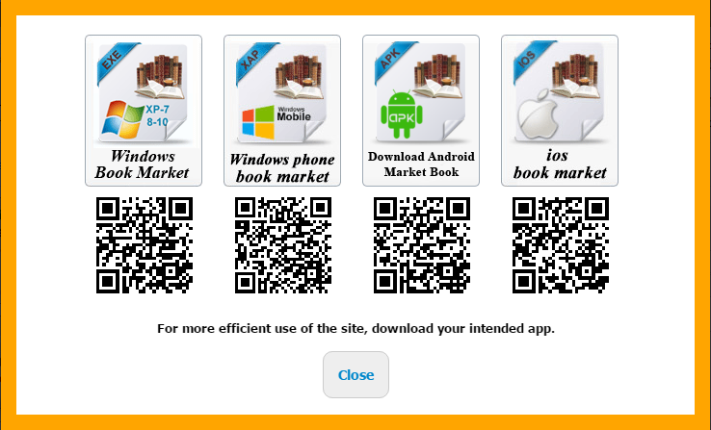
http://download.ghaemiyeh.com/software/ghbook.apk
Note: This help is for users who use Android devices

Bazzar app store
You can search the name “GhBook” in Bazzar and download and install the app.
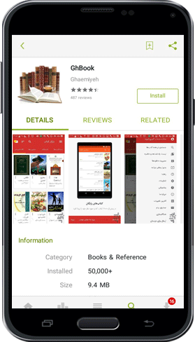

Install Gh-Book App

Allow Unknown Sources
During the installation if you see an error as shown in figure below you need to go to (Setting)>> Security and activate the option “Unknown Sources”.
pic
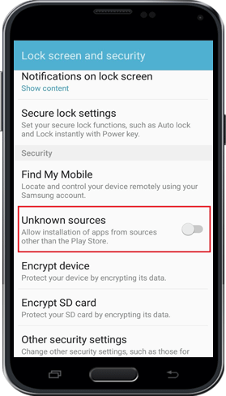

Installing the App
Follow up the installation step. Wait until the installation is done and run the app
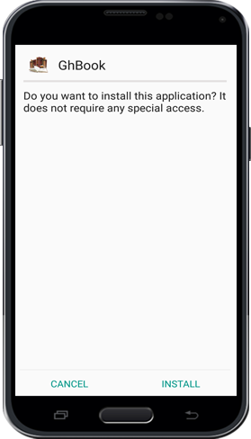
pic
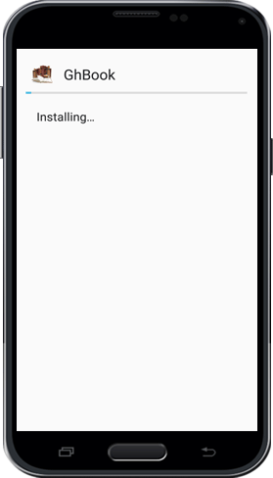
pic
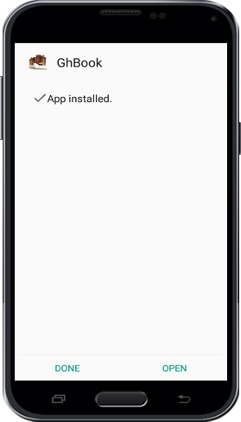

Running the app

Point
When you open the app for the first time the app request for permission to use SD Card. Click on “Allow” to give access to SD Card.
pic
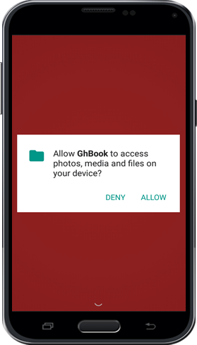

First Time Entering

Point
When you use the app for the first time, you will see the figure below which contains 4 parts:
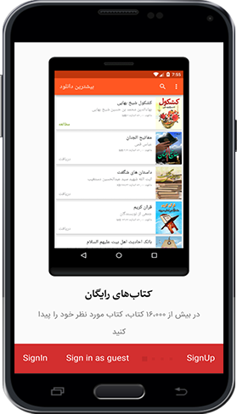

1-Pictorial Help of Gh-Book
In this section, you will see general features of the application as several pictures sliding from left to right.

2-Sign Up

Point
To save user’s information such as list of notes, list of downloaded books, favorites, comments, highlights and all changes that user made on books in Ghaemiyeh’s server and use of these information, user is required to sign up. You can use an email to sign up easily. Thus, click on sign up option.
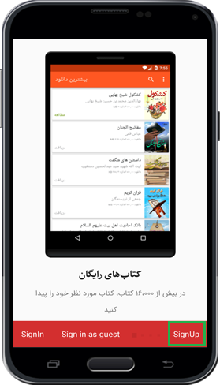
Now to complete sign up process you can choose either of the following ways:

Using Google Account
If you have used your google account previously on your phone or tablet, by clicking on option “Using Google Account” your google account is shown and by choosing that you will proceed to next step.
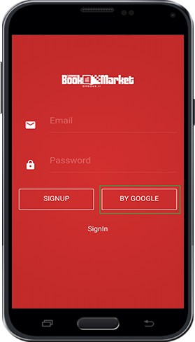
pic
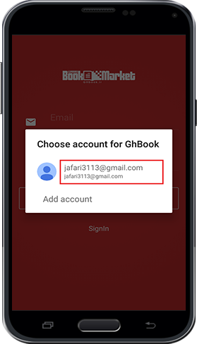
NOTE: If you have not used your google account previously on your device, after clicking on “Using Google Account” option you can add your account (Gmail) to your device.
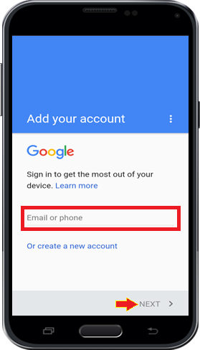
After choosing your google account you will procees to the final step of sign up which has 3 parts:
1-Full name
2-Mobile Number
3-Education Level
Eventually click on “Finish” option. Your account is registered and you will be directed to the main page of app.
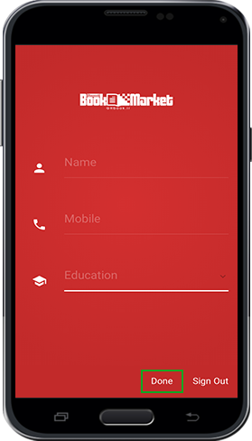

Using non-google Email
Enter your Email address and choose a password for your account. Then, click on “Sign up” option.
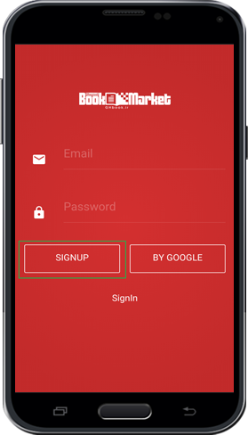
Next, fill up your details as explained in previous section and click on “Finish” option.
Your account is registered and you will be directed to the main page of app.

Sign in as a Guest
If you don’t want to create an account, you can use the app as a guest. However, your account details are not saved in Ghaemiyeh server.

Sign in
If you have registered in this app before and you have signed out, you can click on “Sign in” and filling up your Email and Password and sign in to your account again and access to your account information. Also, you can use and access to this account in any other Android devices rather than your current device.
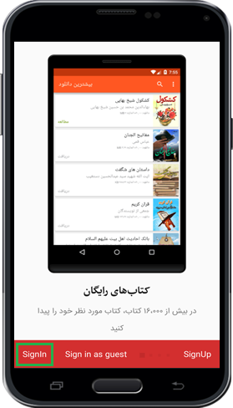
pic
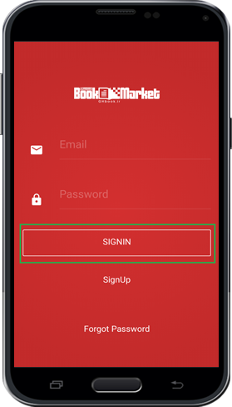

Password Recovery
If you forget your password, go to sign in page. (in the main page in the main menu click on “ Sign up| Sign in” As shown below)
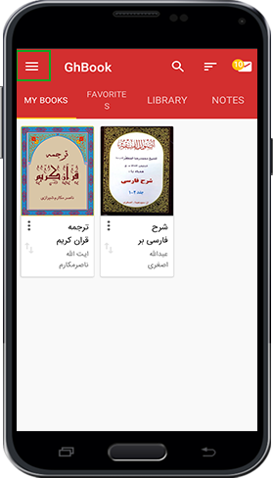
pic
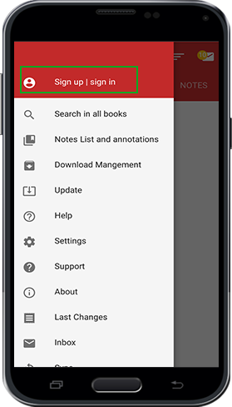
In the new page, type in your email and click on “Forgot Password”.
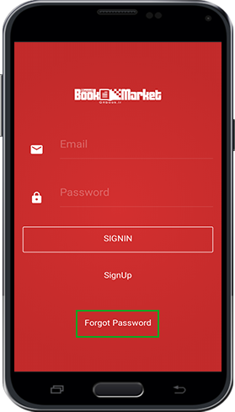
In a few second, you will this message "Change link is sent to your email". Through this message you have received an email containing the password recovery link.
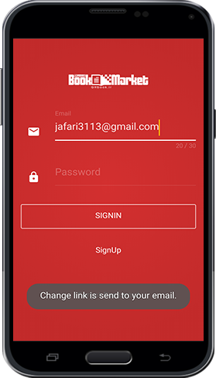
In your email inbox, open the email received from Ghbook store and click on the recovery password link to open the page for changing password.
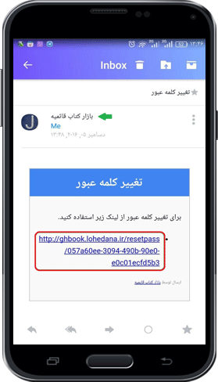
NOTE: To access to the Email you should refer to your own email inbox.
In Changing Password page type the new password in the first box and repeat the new password in the second box and click on “Submit”. You will see the message “The password is changed successfully”. Now you can access to your account again.
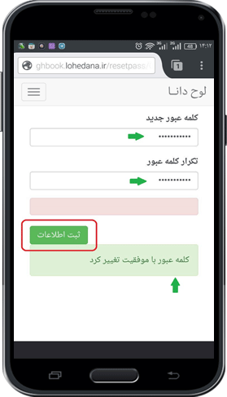

Main Page

Point
After signing in the app, you see the main page which contains 2 main parts:

1-Top Taskbar
It contains the Main Menu, Search tool, Ordering Book tool and Inbox.

2-Main Tabs
Contains 4 Tabs ” Notes- Library- Favorites- My Books”
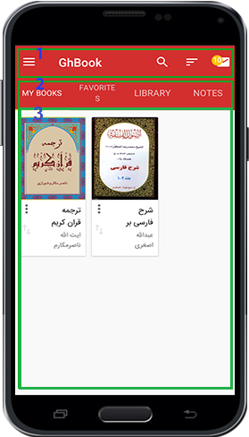

Introduction to the Software

1-Main menu

Point
The main menu includes the general options. Following, each option is explained in details;
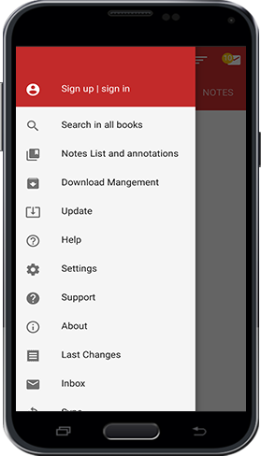

1-Profile
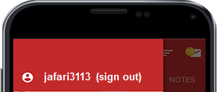
In this section the details of the user is shown. By clicking on this option, the same page you saw during
sighing up is shown. You can view and edit your personal details or you can sign out here if you have signed in from different device. If you sign out from this device your personal information such as Setting, List of downloaded books, Notes, and your settings and changes in the books will not be accessible anymore.
For Editing your personal details, as mentioned before in sign up step, key in your details in respective boxes and press “Done”.
To exit from your account, just click on “Sin Out from this Account”. You will see a message saying: “by signing out from this account your personal information is not accessible anymore”. However, whenever you sign in again this information will be accessible again.
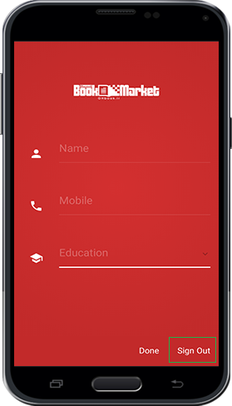
Now by clicking on “Sign Out” you will exit from your account.
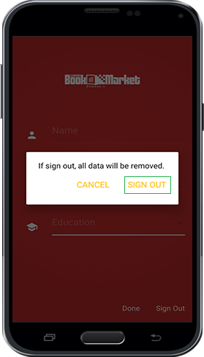

2-General Search Tool

Point
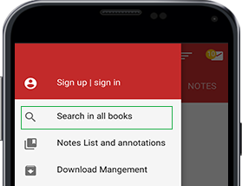
If you want to search a text or phrase in all downloaded books, you can use this option. After clicking on this option, the search page will be opened. You will see all downloaded books.
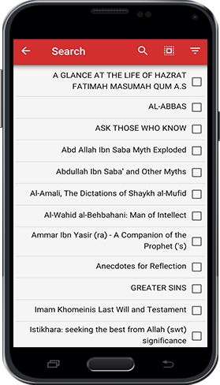
First, choose all the books you want to search in and then click on the search box (the Magnifier icon) so that the keyboard will be opened. Type the keyword or phrase that you want to search and click on search button on your keyboard.
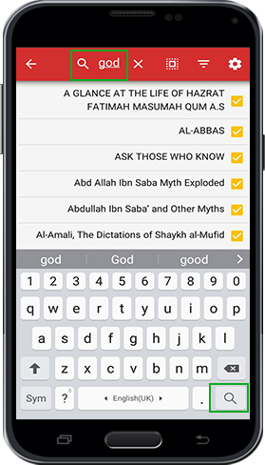
You will see all the books that contains the keyword you have typed while the phrase or keyword is highlighted.
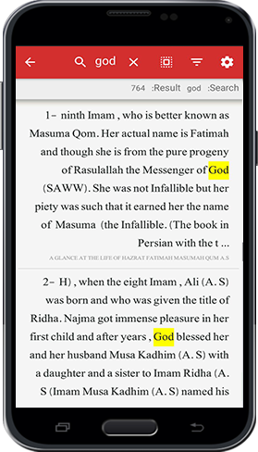
Eventually by clicking on any of the results you will be directed to the respective book.
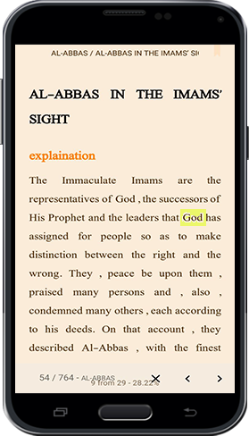

Explanation of icons in search page

Point

; Return to the previous step

; Delete the typed text for searching

; Select all books for searching

; filter the search domain. By clicking on this option a new menu is opened that contains 3 options:
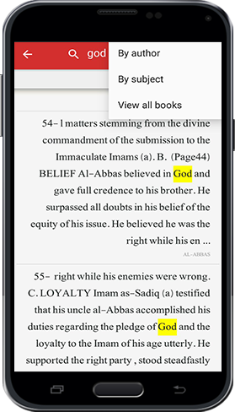
Based on the author: it limits the books based on the author:
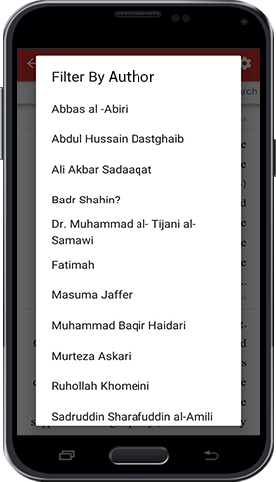
Based on topics: it limits the books based on 26 main topics.
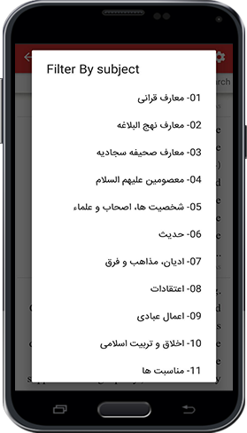
All the books: as you saw before all the result will be shown without any filter or limits.
One of the unique capabilities of this app is the precise and advance search that provides different search option for the user.
By clicking on this option, the Search Setting window is appeared. All the options are explained in details below:

Searching as the word written

Point
One of the unique capabilities of this app is the precise and advance search that provides different search option for the user.
By clicking on this option, the Search Setting window is appeared. All the options are explained in details below:
in default mode if you search a word or phrase, the search engine will search for that specific word as well as all related words. It expands search domain that even the same-root-words are included that in some cases are applicable. However, by choosing this option, search domain is limited and the engine will search only the exact word you have entered.
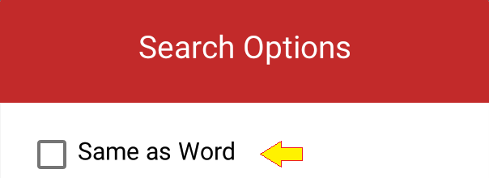

Multi-Words

Point
By clicking on the arrow in front this option a menu is opened which contains 3 options:

1-All words without order
When you are searching more than one word, this option enables the search engine does not consider the orientation of the words and will search all the typed words. This option is useful when you typed the words without any specific orientation or it is not important.

2-All words with order
in contrast to the option 1 this option consider the order of the words

3-At least one of the words
if you want to search several words in a book but you do not know which one of those words exist in the book, you can type all those words and choose this option. Thus, the search engine will search all the texts which contains at least one of these words.
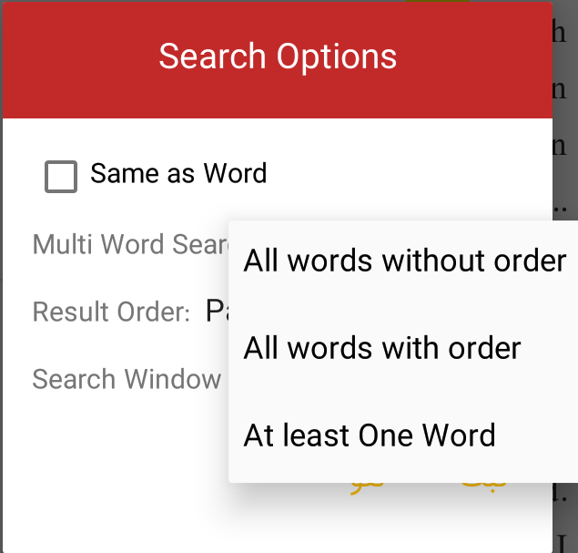

Order of Results

Point
Organizing the result of search based on 2 parameters.

Page Number
The results will be displayed based on the page number of that text which contain the searched words. That is, those results which have smaller page number will be displayed first

Degree of similarity
If you have not chosen the option “Searching the Exact words” the result will be the exact words (if exist) or similar words. Thus, to organize the results based on more similarity, this option is considered.
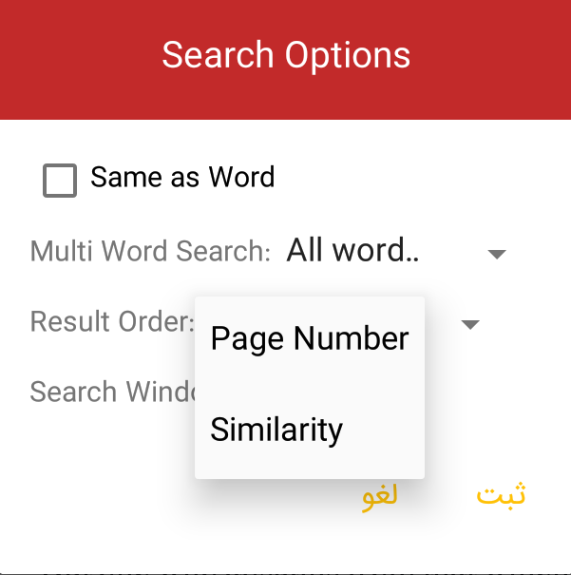

Search Window
You might want to search some words but you don’t know the distance between the words. Thus, by choosing one of the numbers as shown below, you can specify that search engine should consider the approximate distance between the words to be high or low.
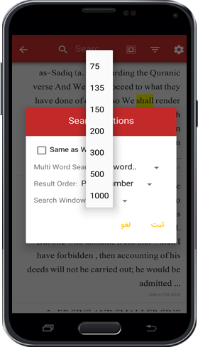
Thus, by choosing bigger numbers, search engine will search the words even if there are several words or sentences between them.
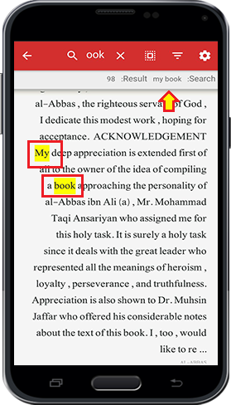

3-Notes list and annotations

Point
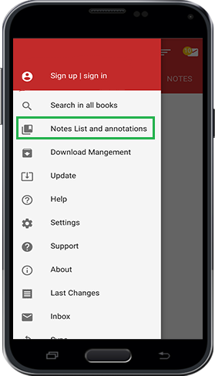
Accessing to all highlighted texts, favorites, and comments that user put on the texts are available in this section. There are 3 main parts:

Highlights
In the texts of the books, you can highlight a text and specify a color of it. Thus, that part of the text is categorized as Highlights and you can access these texts from List of highlights.
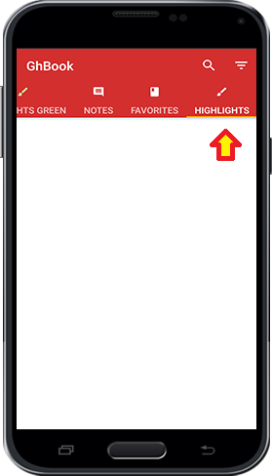

Favorites
As you are reading the book and if you use the Red Ribbon Icon on top of the page, that page is saved as favorites that is accessible from this part.
Notes:
Also, as you are reading books you can type comments and those comments are accessible from here.
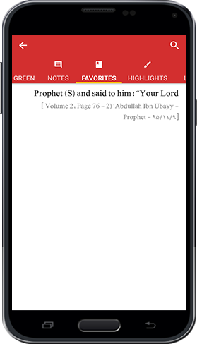
NOTE: as you can see, beside these 3 parts there are another 10 parts which is related to categorizing the Comments and Highlighted texts based on the color.

Explanation of Icons
On top of the page there are search and ordering icons that are explained below:
Ordering; it organizes the highlights and comments based on 3 parameters:
a)Based of time:
The earliest highlighted texts or comments will be displayed first.
b)Based on Position in the Book:
Highlighted Texts and Comments that are in the pages with smaller numbers will be shown first
c)Colors:
The Highlighted Texts or Comments could be displayed based on their color. That is, the Highlights and Comments are displayed based on the selected colors and vice versa.
Therefore, by selecting or deselecting the colors they are categorized or uncategorized.
For example; by unselecting the red color, all Highlights and Comments by this color are not displayed here anymore.
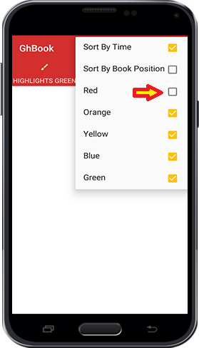
This option is to search in Highlights and Comments. If you have highlighted several texts and put comments in several texts, you can find a specific Highlights or Comments by searching a part of that text in this option.
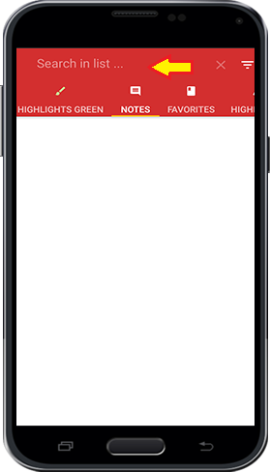

4-Download management
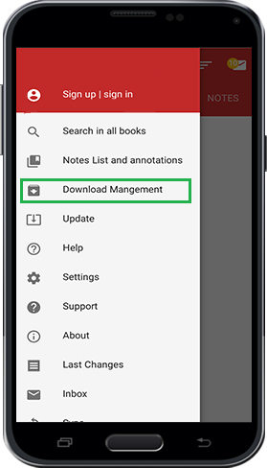
The downloaded books or the books are being downloaded are displayed here.
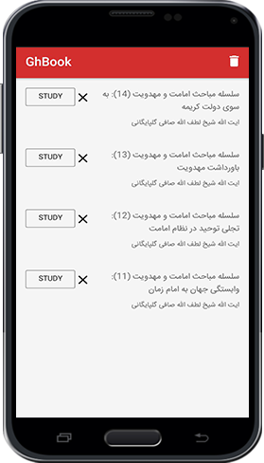
Explanation of Icons
Pause Download: by choosing this option the download is paused temporarily.
Restart Download: After stopping download it restarts download.
Delete: if the file is downloading, by clicking on this option the file is deleted and is not downloaded anymore. If the download is done, by clicking on this option the installed file is deleted but the downloaded file is not deleted.
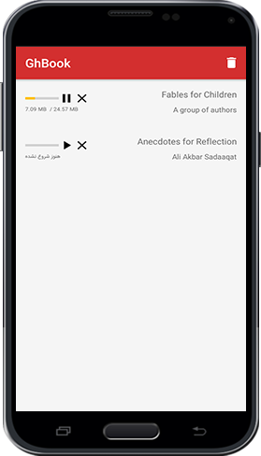
By clicking on the Bin icon on top of the page all the installed files are deleted. However, as mentioned before, the downloaded files are not deleted from app. Only installed files with the suffix of (Ghm) which exist in the downloaded files is deleted.
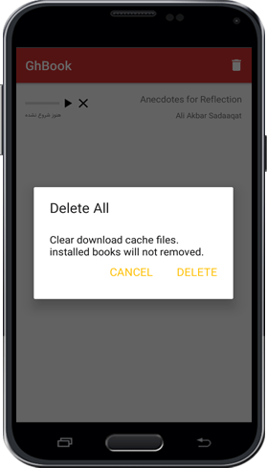

5-Update
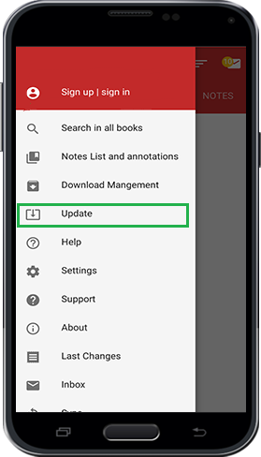
To know about the latest books in Gh-Book app your library should be up to date. Thus, if the list of books is changed the app will show you a message to update your Network library that you can update the library from there. However, if you want to update the library manually you can use this option.
Also, for updating the app itself you can use this option as shown below:
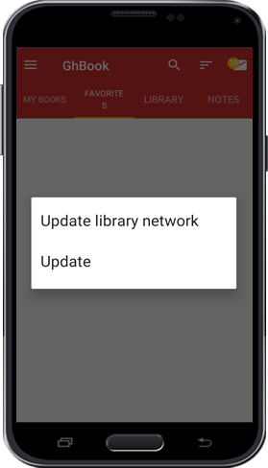
NOTE: If your library is up to date or your app is the latest version. You will receive a message saying that you don’t need to update the app or library.
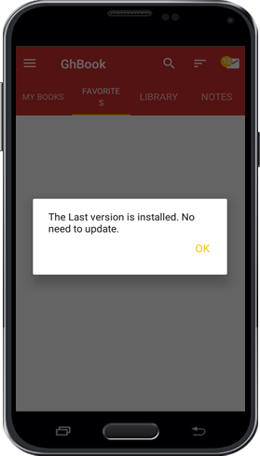

6-Help
Anytime you will be directed here if you choose this option.

7-General Setting

Point
General setting of the app is accessible here such Language Setting, view of text, Sharing and other settings that user could do in this app could be accessed here.
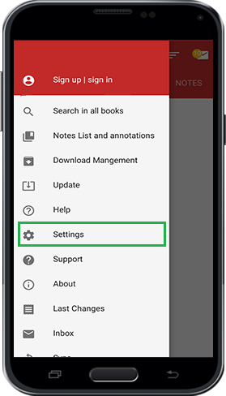
pic
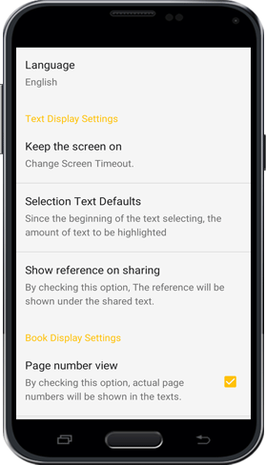

Language Setting
By clicking on this option a window will appear which enables the user to change the language of the software. Therefore, by changing of the language of app, the language of menus, topics, messages, and settings will be changed.
However, changing the language of the app, the language of the books is not changed.
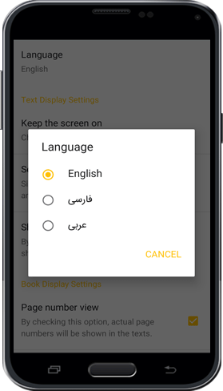

Text Display Setting

Point
It contains 3 sections:

1-Keep the screen on
By choosing any of the time limits, the screen will be on based on that specific time chosen. However, choosing the option “Always” will keep the screen on as long as the user is reading.
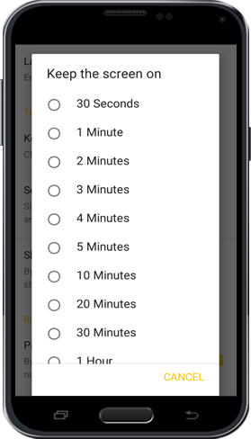

2-Selection Text Defaults
this option specifies the amount of text to be selected while the user touches the screen for several seconds. For example, if the option “Whole Page” is chosen, if the user touches the screen for a long period, whole page will be selected. However, by moving the markers this amount could be changeable.
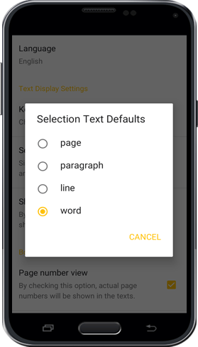
pic
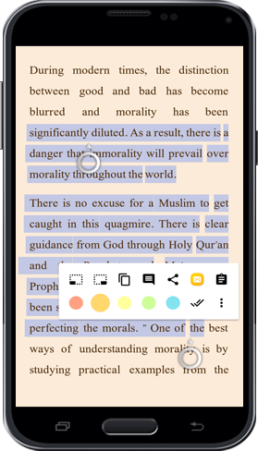

3-Address Setting in Sharing
While you want to copy or share the selected text, you can specify the address of the page or the location of text in the book at the end of copied or shared text. Also, there are several parameters which helps to manage this additional information at the end of copied text such as address or source.
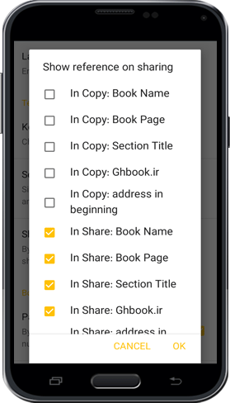
For example, by choosing these options as shown above, the shared text would be as below. Address is mentioned at the end of the text as well as link of the book in Ghaemiyeh website.
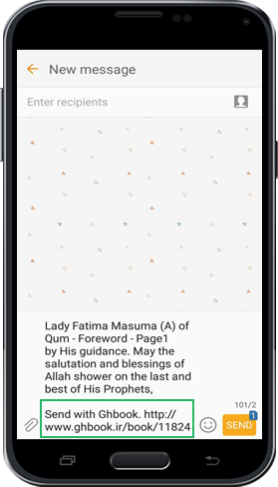

Book Display Settings

Point
It has 3 sections:

1-Page number view
Since the standard layout of book is unique in Gh-Book, and there are some mistakes in digital layout of some books, Ghaemiyeh team has redone all the layouts and corrected the mistakes. Thus, by choosing this option, the real page number based on the standard of Ghaemiyeh is displayed.
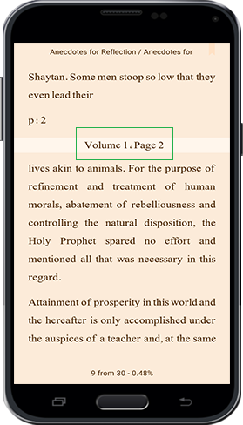

2-Layout by actual pages:
By choosing this option, the real page number is shown at the bottom of the page and end of each page is equivalent to the end of the page in the real book. (However, previously beginning of the next page was shown at the middle of the same page)
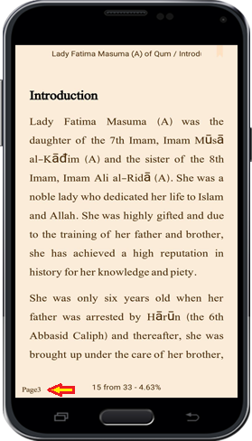

3-Select text with double tap
By double-clicking on the screen, you can select text.

Taking Note Settings

1-Opening Notes
By activating this option, after you type a note, you will receive a message asking for displaying the note or not. Thus, by clicking on “Display”, the note will be displayed and by clicking anywhere else out of box the message is disappeared and the note is not displayed.
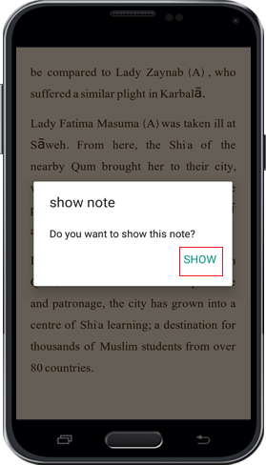

2-Number of last selected note's subject
This option specifies that how many notes to be displayed while you are saving a new note.
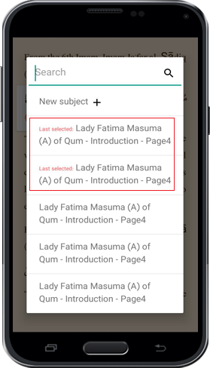

General Setting

Use SD Card
By choosing this option, if you phone or tablet has side memory, books will move to side memory.
If you activate this option and the app is deleted, all the books will be deleted as well. However, by deactivating this option, (the app is on main memory), by deleting the app, books are still in the memory. That means, if you install the app
again, you can see the downloaded books again.
Note: If you have registered your account in the app, by activating this option or not, some information such as list of downloaded books, list of notes, settings and … are save on Ghaemiyeh server. And if the app is deleted, this information is still accessible.

Delete Network Library
If you want to access the latest list of Ghaemiyeh books, you can delete the network library by clicking on Bin icon. Thereafter, you can again receive the list of books from main page and menu “Library” or option “Update Network Library” from the menu “Update the application”.
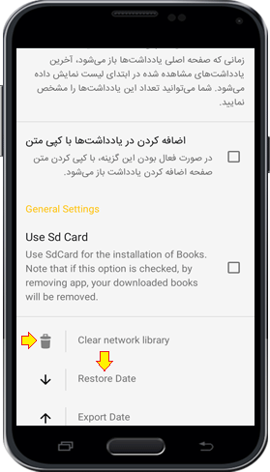

Saving Highlights, Favorites, and Comments(Data)
IF you have not registered in the application, list of favorites, comments and highlights will be deleted by deleting the app. Thus, create a backup from them, you are able to save the list of favorites, comments and highlights on the memory of your smartphone or tablet. Therefore, click on the arrow pointing upwards.
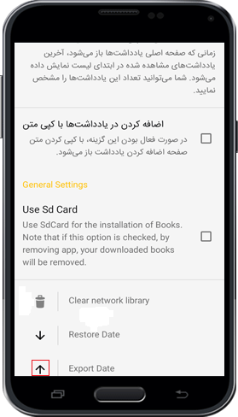
In the new page appeared, specify the location of the backup file to be saved. For example, in the figure below we have created the folder “یادداشت های بازار کتاب” manually.
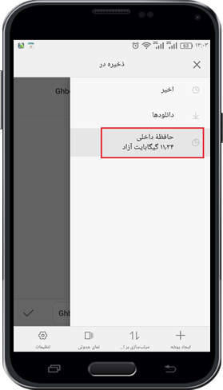
pic
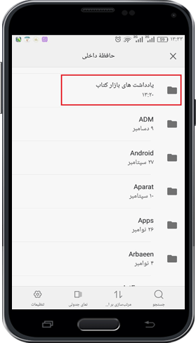
After specifying the location, by clicking on tick icon at the bottom of the page, the backup file is saved.
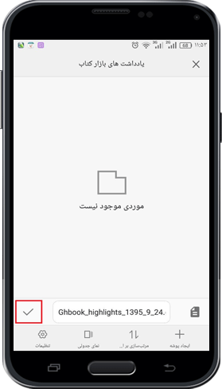

Recovery Comments, Highlights, and Favorites(Data)
If you have saved the comments, favorites and highlights somewhere in your phone or tablet before and in case, if they are deleted, you can recover them by clicking on this option. Therefore, click on the arrow pointing downwards.
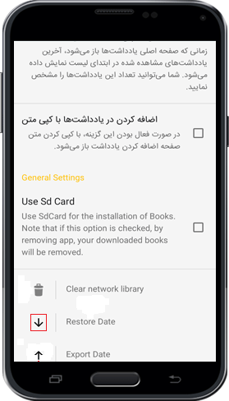
Next, refer to the location you have saved the backup files previously.
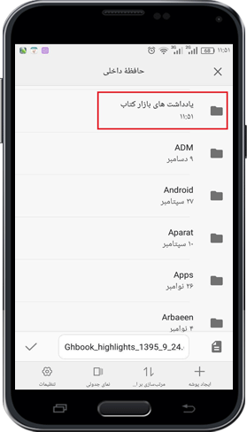
Now, by choosing the backup file all highlights, comments and favorites will be recovered.
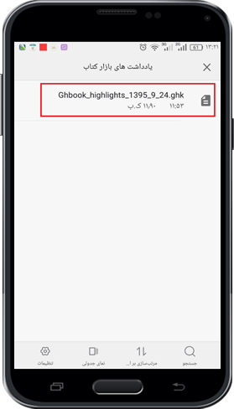

8-Support
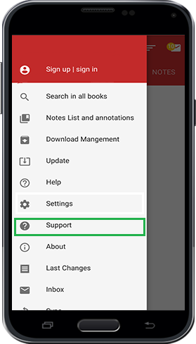
To contact Gh-Book Customer Service, you can give suggestion, or submit complain from this platform.
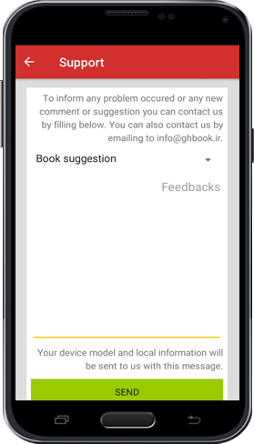
Thus, you might choose any options from the menu opened (As shown below). Then, type your suggestions, message or complain and click on “Send”.
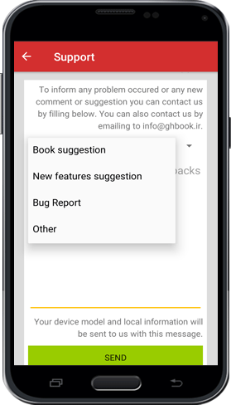

9-About Us
Some information about Ghaemiyeh Research Center in Isfahan such as Manifestos, Objectives, Politics, Activities, and ways of contacting with this center.

10-Last Changes
List of the latest changes from the latest version of app

11-Inbox
The Messages from management to users of Gh-Book are accessible here.
Note: By clicking on double-tick icon on top of the page (as shown below), the app will consider the message as read and the inbox icon is not shown in the min page.
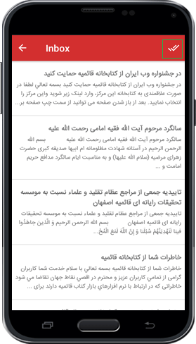

12-Sync
Synchronizing the app with Ghaemiyeh server to send and receive information and data.

13-Share App
to share the app “Gh-Book” with sharing applications, you can click on this option and choose the application for sharing.
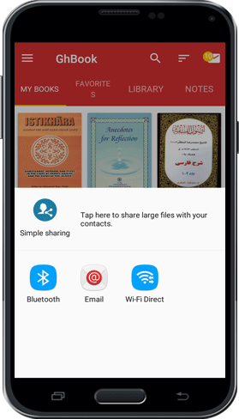

2-Main tabs

Notes

Point
Access, editing and changing Notes
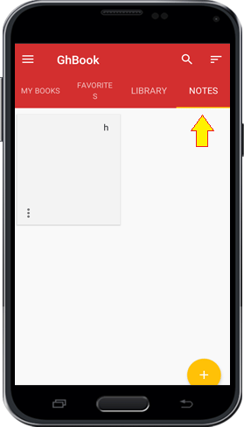

Notes Setting

Point
By clicking on Note Setting icon on the bottom of each note, a menu is opened which contains 3 options:

Editing
For editing the Notes

Delete
For deleting a note

Share
Sharing a note with other applications
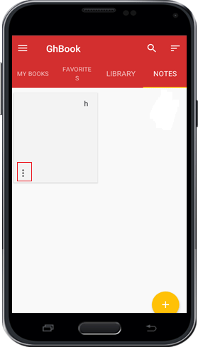
pic
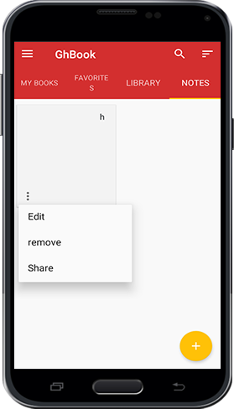

Send Notes to categories
To move note(s) to collection(s) of notes, you can touch that note for several seconds. Then, select all the notes you want to send (mark the tick icon beside each note). Thereafter, click on the folder icon as shown in the figure below to view the list of all category folders. Also, you can delete the selected note(s) by clicking on the Bin icon.
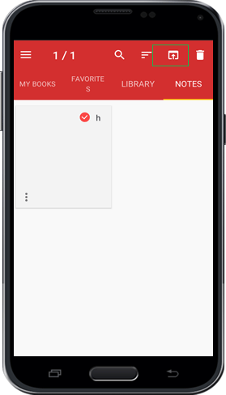
Eventually, by selecting any category and clicking on “confirm”, the selected note(s) will move to the categories.
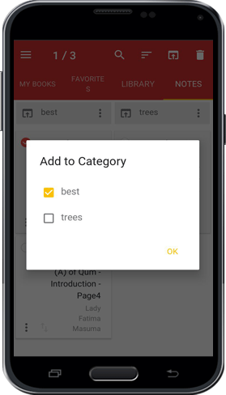

Adding Notes

Point
To add a new note or collection of notes, click on the + icon on the bottom of the page.
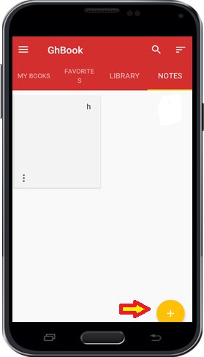

New Notes
To create a new note click on this option and then type topic of the note. Then, type or paste the content of the note and click on return key in your phone or tablet. Your new note is created and saved.
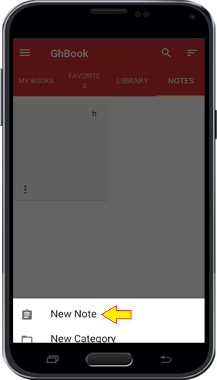
pic
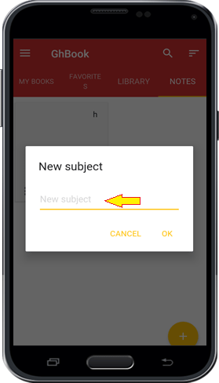
pic
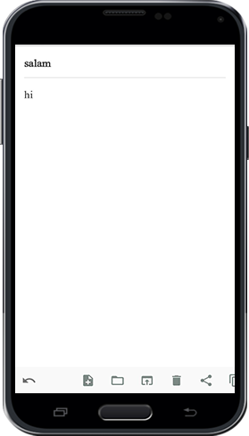

The Category
This platform is to organize and categorize the notes based on different topics for the user. the user is also able to create category of different notes based on various topics.
Click on + and then choose “New Category”.
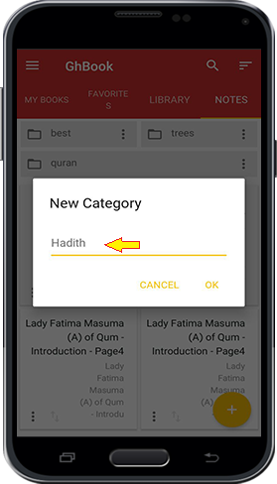
pic
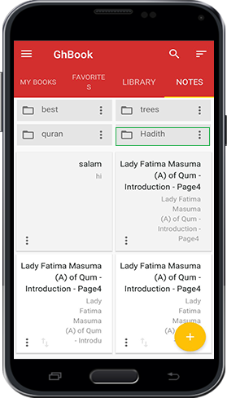

Setting for category of Notes
BY clicking on Setting sign in category of Notes, you see three menus such as Setting for category of Notes. The use of each menu is based on previous explanation. The option “Share as File”, saves the notes as a file or the format of a text.
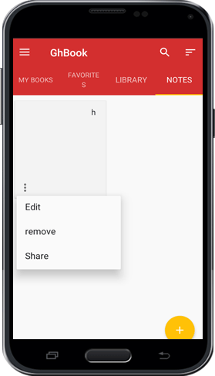

1-Library
As mentioned before, all books are categorized based on different topics such as Quranic Education, Education of the Book Nahjulbalagheh, Hadith, Believes, Occasions and... in different collections. By referring to each collection you can choose your desired books and topics.
The section “New Books” contains the newest 500 books which are on the server of Ghaemiyeh and the section “Most downloaded” contains the most 500 books downloaded by users.
Note: If you are not able to see the categories of Books, your library is not updated. You should upgrade the Library with the same way as mentioned before.
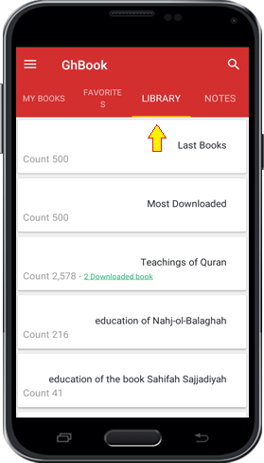

2-Favorites
User’s favorite books
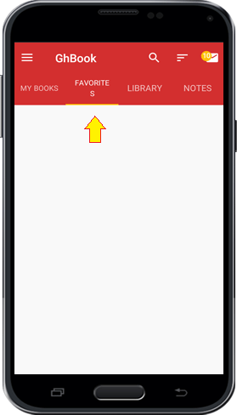
To separate the books you are dealing with more or your favorite books, you can add them to the list of favorite books. To do so, inside menu “My Books” click on menus button and choose the option “Add To Favorites”.
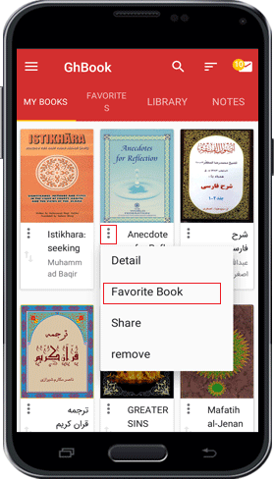

3-My Books
All downloaded book:
All downloaded books are shown here.
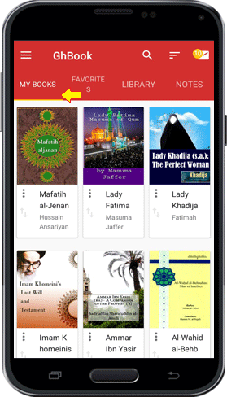

Setting of books in Local Library

Point
In the section “My Books” and in “Favorites”, by clicking on the menus button on the corner of each book, there are 4 options as below:

1-Details
In this section the details of books such as publication, language, topics and editions, appearance, the picture of the book and … are shown.
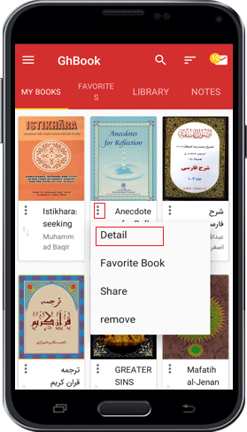
Donation:
As far as Ghaemiyeh has the permission and license from authors and publishers, reading and copying all the books are completely free. However, the users can pay any amount as donation, gift, or Imam’s Share to be part of us in publication and distribution of Shia’s Book. To do so, by clicking on option “Donation”, you can see 2 option for donation:
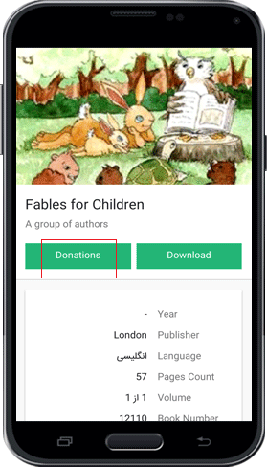
pic
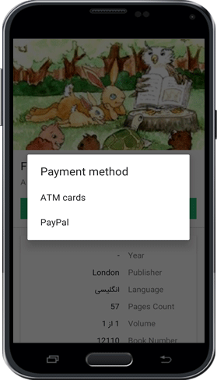
Pay with ATM card (from the banks which are the member of SHETAB SERVICE):
All users who have the ATM cards (from the banks which are the member of SHETAB SERVICE) can easily pay any amount using ATM Card Number and Internet passcode.
Pay with PayPal:
Those users who have PayPal account or who wants to pay via PayPal, are directed to the PayPal webpage by clicking on this option. Now by clicking on this option “Donate Now” the payment webpage is opened and by choosing the amount and filling the form you can proceed with payment.
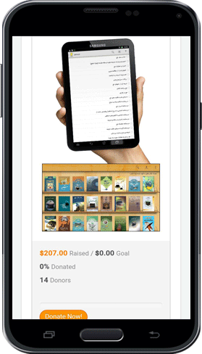

2-Add to Favorites
This option adds the books to the favorite list so that you can easily access to your favorite books.

3-Share
Sharing the link of the books in Ghaemiyeh Website through other software’s.

4-Delete
Deleting the downloaded books

Ordering Books and Notes

Point
To organize or have a different view of the downloaded books and notes, you are able to change the layout of the books and notes from Home Page. To do so, whenever you are in the tabs “My Books”,” Favorites” or” Notes”, you can see the Organize icon. By clicking on this icon several options are opened.
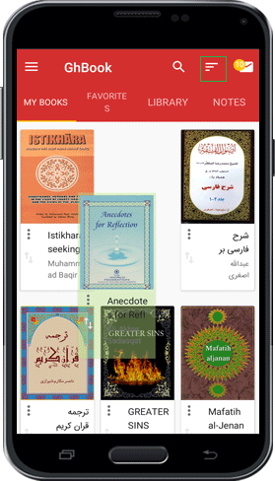
pic
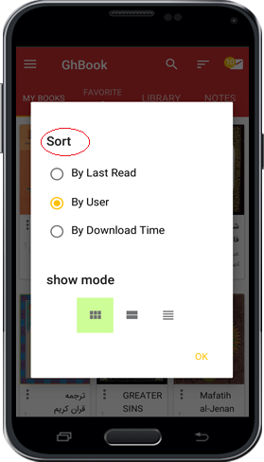

By Last read
By choosing this option all the books which are studied recently are shown first.

By user
By choosing this option the user can drag and drop each book to customize and organize the books. To do so, you can use the two-arrow icon and put your finger on this icon to drag the book and move and drop anywhere you want.
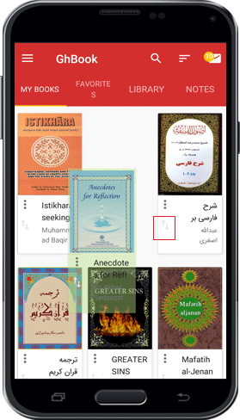

By Download time
By choosing this option, the recent downloaded books are shown first.

Views of Books
To have different views based on the details, 3 options are considered:
1st option (Large icon); 3 books in each row with the picture of the books.
2nd option (Content); one book in each row with the picture of books
3rd option (List); all books are listed vertically without any picture.
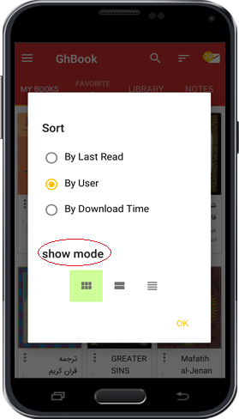

Inbox
You might see the Inbox icon in the Home Page. As mentioned before, messages from management to the users could be seen in Inbox. However, if the user has viewed all the messages and not new messages are received, the Inbox icon are not shown.

Search in All Books
You can search more than 16 thousand books!
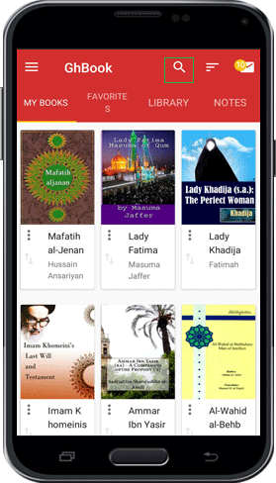
To ease searching, the search icon (like magnifier) is accessible in the Home Page. Thus, if you have upgraded your library, you are able use the search tool in the main page and search among all titles and authors in Ghaemiyeh’s servers.
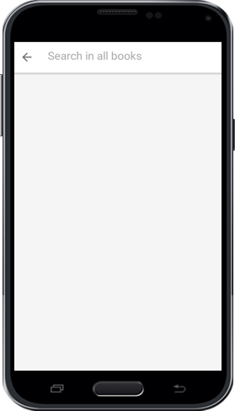
Thus, you can type the title of the books or the name of author in the box and click on the search button on your keyboard.
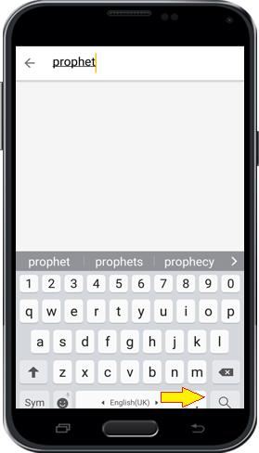
pic
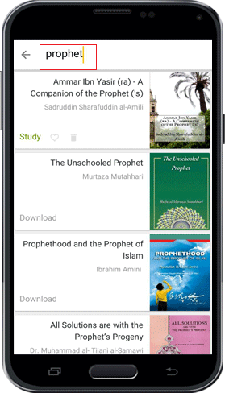
pic
After finding your book, by clicking on “Download” you can download the book.

Reading book

Point
The app “Gh Book” has a special focus on the studying of the content of the books and because of that it has provided various and useful facilities to facilitate studying and citation of books for readers and researchers. In this section, all the facilities and tools for studying is explained.
In the page of the text of the book you can see the title of the book and the topic of current season on top of the page that by moving that to the right and left you can see your current position in book based on seasons and section of the book. By clicking on it you will move to the table of contents.
In the bottom of the page has two sections. On the right side of the page, the page number of the page in the current season is located and on the left side the location of the current page based on a percentage of the whole book is shown. Thus, the number on the right side might become zero several times during reading and start over. However, the number on the left side shows the percentage of amount of book which is read.
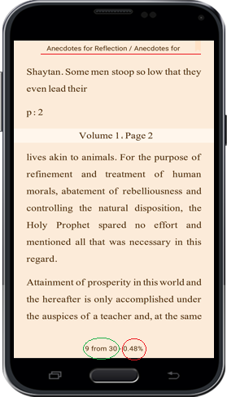

Reading Tools

Point
By clicking on the screen, two white boxes appear on top and bottom of the page that contains different tools.
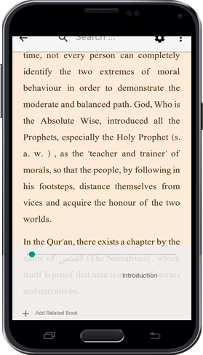

Setting of the page

Point
Whenever you have seen the boxes on top and bottom of the page by clicking on the Options icon on top corner of the page, another menu is opened that contains 3 different settings:
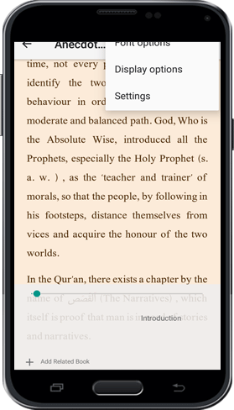

1-Font options

Point
By clicking on this option, you can see a menu containing different font setting as below:

Font name
By clicking on the box of the name of the books a sliding menu is opened that you can select your desired font.

Font Size
By clicking on negative sign (-) the font size decreases and by clicking on (+ ) sign font size increases.

Margins
You can decrease or increase the margins

Line Spacing
The space between each line could be changed (decreased or increased)

Justify
Distribute your texts evenly between margins

Right to Left
It is used for Persian texts to show the texts from right to the left.

Diacritic
Choosing this option will show the diacritics.

Colored Diacritic
By choosing this option all diacritics will appear in color that the color could be change from the box below the option.
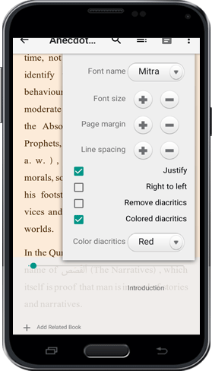

2-Display options

Point
Includes the setting for the view of the texts:

Theme

Point
It has 3 Modes:

Day
It sets the background color of the text to white

Night
It sets the background color of the text to black

Sepia
The background color of the text is set to default mode (Sepia Color)

Brightness
If the (Auto) mode is off, the brightness could be adjusted by sliding the button.

Orientation

Point
It has 3 modes:

Auto
In this mode by rotating the phone the text will rotate horizontally or vertically.

Vertical
The orientation of the text is fixed vertically and by rotating the phone, the orientation is not changed.

Horizontal
The orientation of the text is fixed horizontally and by rotating the phone, the orientation is not changed.
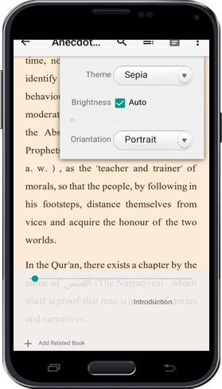

3-General Settings
This section is already explained

Refer to Notes
By clicking on this icon, you will be able to refer to the notes at any time while reading books.
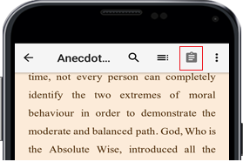

Index of books
Refer to table of contents of the book.
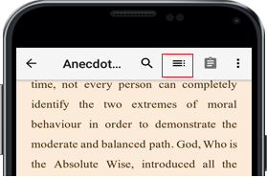
By clicking on this icon, you will be directed to table of contents. Except the table of contents, all other materials are explained before.
In the table of contents, by clicking on the title of Chapters of the book, you can see the sub-titles of each chapter and by clicking on each title you will be directed to the main text.
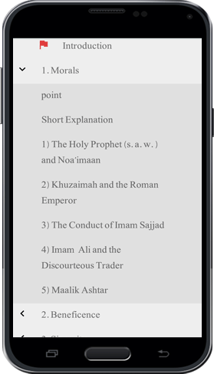
Also, the red flag icon shows the current position of the book which is read based on the chapters of the book. By clicking on that flag, you will be directed to the beginning of the chapter.
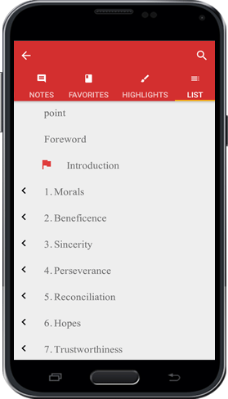

Search Tool
You can search words and phrases from texts in the book precisely as explained before.
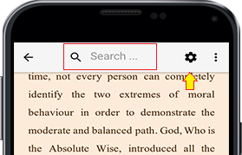

Return Key
By click on this icon and you will exit from the text and will be directed to the main page.
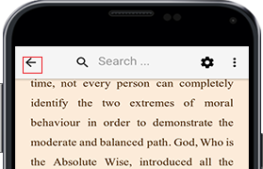

Quick navigation between Chapters
As far as each book has different chapters, you might want to refer to different chapters frequently. Thus, each time you might need to go to table of contents and go to that desired chapter. However, with this feature provided in the app, you can easily refer to previous chapters and the latest chapter which you have read currently.
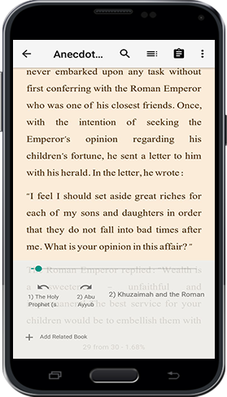

Add Related Books
Imagine you are reciting AL-QURAN AL-KARIM and you are interested in the interpretation of a verse of QURAN, and, there are some words or vocabularies that you don’t know the meaning and the root of the word. Thus, if you want to find the interpretation and the meaning, you need to referrer to several books that makes you to exit and open several books. However, to ease the process of the navigation among the related books, during reading of the book all related books are listed below the text. User, also, can add the related book themselves so that all the related books could be easily accessible.
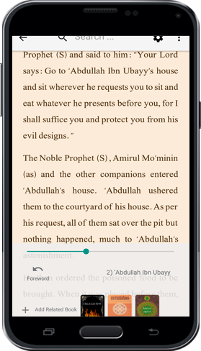

Tagging Pages of Book
During reading the actual book, if you want to tag or mark a page for the future refer, you need to place an object between the pages of the book. Thus, if the number of the tagged pages are high this method gets more difficult and finding a specific page is harder.
Thus, Gh-Book app provides this feature that you can mark several pages and save them under the title favorites so that you can easily access to them later. Thus, to mark the pages during reading, click on the red Ribbon on top of the page. However, by default the ribbon is pale (The color is faded) to distinguish whether it is used or not. Also, you can assign a name for that page as a title.
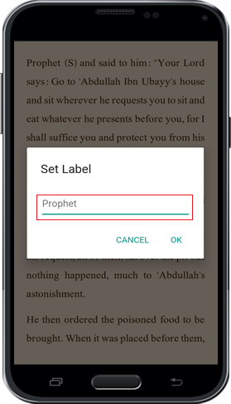
pic
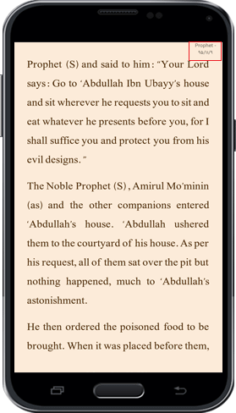
To access the favorite pages of a book you can go to the table of contents of the book and choose the favorite menu.
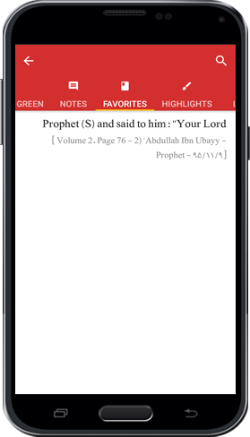
Also, to access to the list of favorites that you have assigned from different books you can refer to that main page as mentioned before.
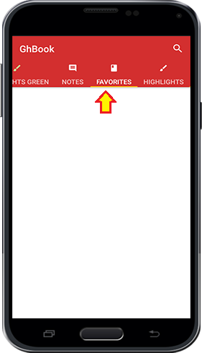

Text selection tools

Text Selection Handles
During the selection of a texts usually we face this difficulty that a part of a text is from one page and the rest is from the next page. This force us to select the text several times separately. However, in Gh Book this tool is provided that you can easily select long texts and multi-pages texts one time and copy right after that.
To select a text, you can double click on a word or hold your figure for several seconds on the text. When the selection tool is activated you can see two handles appeared. By moving these two handle you can choose your text. (The default size of selected text is mentioned in the text selection setting). In this case, you see that two arrow symbols on at the top and bottom of the screen displays that by clicking on them you can select the texts from next and previous pages.
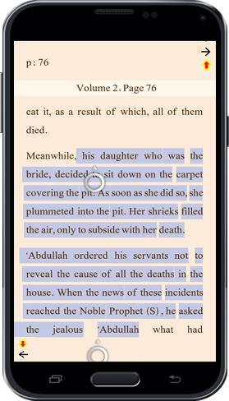

Selection Menu

Point
A set of tools, that includes multiple options, is appeared when a text is selected. Below is the description of these tools:
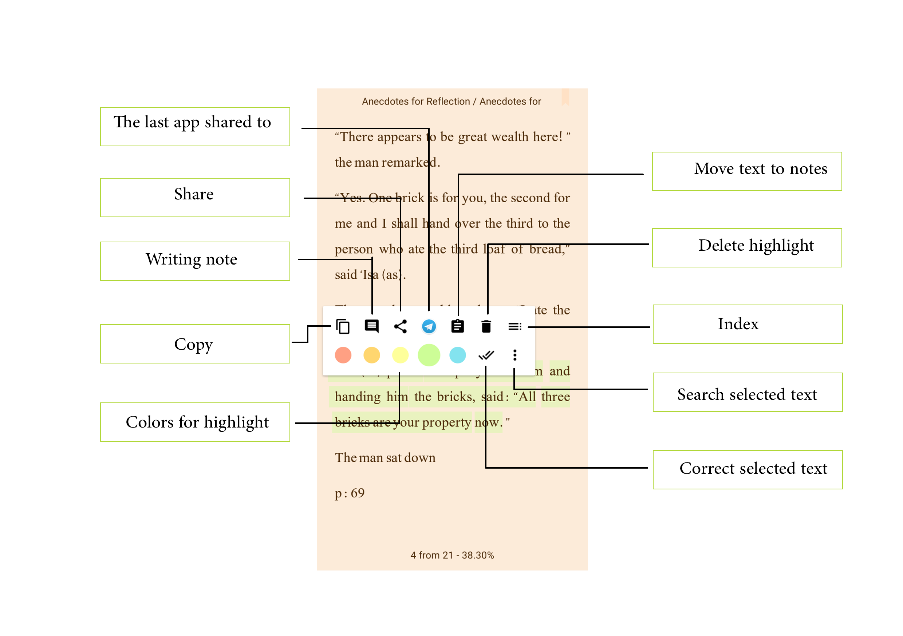

Moving Text to the Notes
By clicking on the notes icon after selecting a text you can copy the text and move it to the notes.
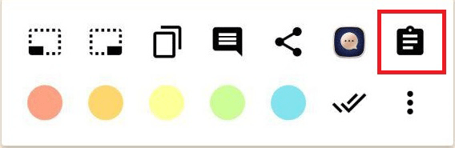

Moving Text to the last software which is used for sharing
In this part the last software that user used for sharing is shown.
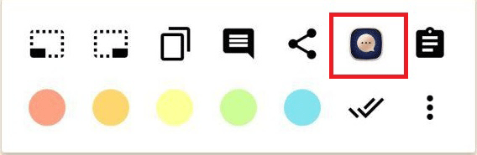

Share the Text
To share the text with related softwares.
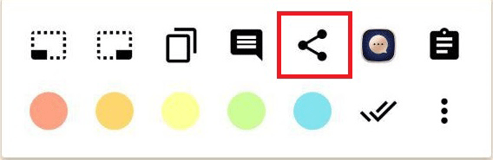

Writing Comment
If you want to write a comment on a part of the text, you can choose this icon after selecting the text and type or copy your comment.

pic
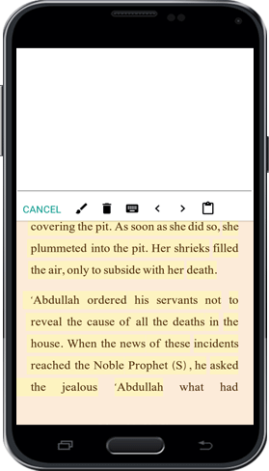
In this case, you can navigate between all the comments in the book by clicking on the arrows pointing to the right and left.
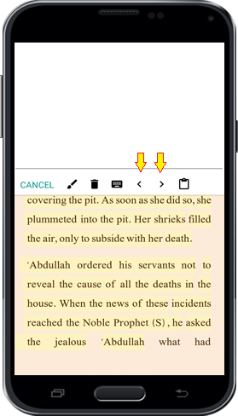
By clicking on bin icon, you can delete the comment.
The Brush icon is to save the comment.
The attach sign is to copy and paste the text.
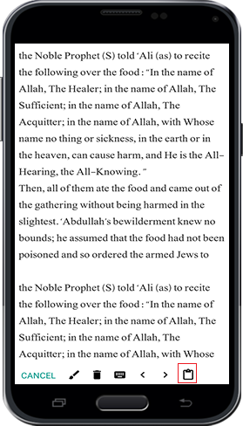

Copy
After selecting the text, you can copy the text in clipboard memory by clicking on the Copy icon. Subsequently, you can paste the text anywhere you want.
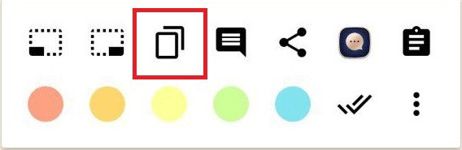

Multi-page text selection
Another useful tool in selection is multi-page selection that you can use these two icons. The left icon is to add the previous page and similarly the right one is to add the next page.
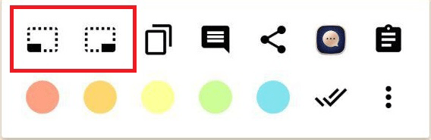

Search the selected text

Point
You are able to select a text from book and search it in the book, other downloaded books, digital library in Ghaemiyeh website, Google and in Wiki Feghh website. Or even you can use google translate to translate the text to different languages. Thus, to do so, click on the option icon on the right bottom of the menu to see different options as bellow:
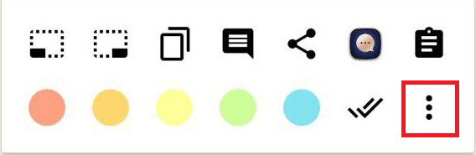

Search in the Book:
The selected text is searched in that book.
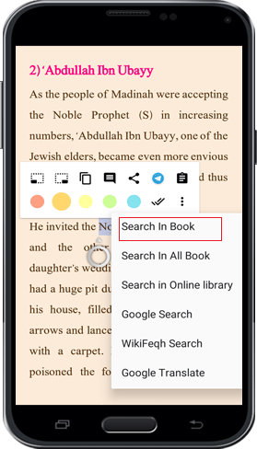
pic
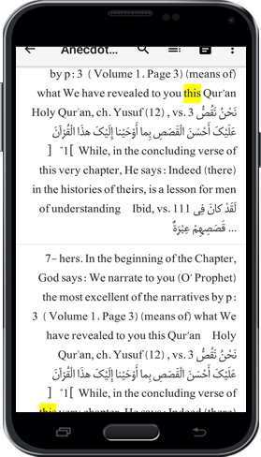

Search in my Books
The selected text is searched in all downloaded books

Search in Online Library
The selected text is searched in the digital library of Ghaemiyeh
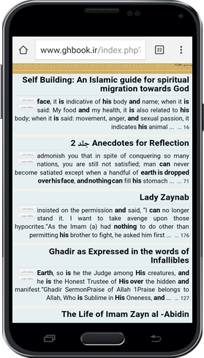

Search in Google
The selected text is searched in Google website

Search in Wiki Feghh
The selected text is searched in Wiki Feghh website

Google Translate
The selected text is translated to other languages with Google Translate

Text Correction
One of the most useful features of this app is that user can correct the mistakes of the text of books.

First, select the text which contains mistakes (Wrong Text) and after you see the Selection Menu, click on correction icon (which is double-tick icon as shown below). Now you see the selected text in edit mode. Then copy the corrected text and click on “Send us the Correct Text”. The corrected text is sent to us and we will correct the text after checking.
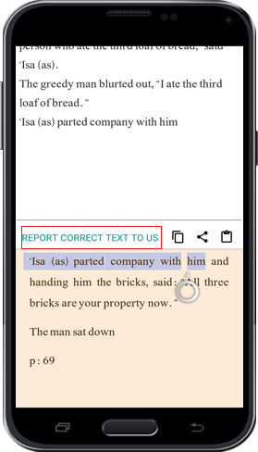

Highlight Text
To distinguish a part of a text you can highlight it with different color. Thus, select a part of the text, and after you see the Selection Menu choose any color you want.
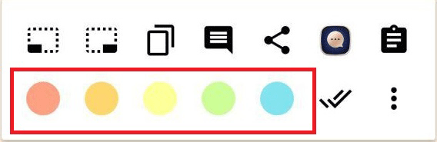
To remove the color from the highlighted text, click on the highlighted text, after the menu is opened, choose the recycle bin icon.
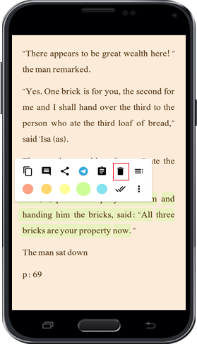

ghaemiyeh.com

