

Beautiful moments with Imam Mahdi


ghaemiyeh.com

فهرست مطالب
book id 4
Point 4
One glance could prevent you from seeing Imam al-Mahdi 10
The Pomegranate 18
Imam Mehdi And Abbas ibn All 26
The soap man 28
Imam Mehdi and al- Hurr al-Ameli 32
Look at how my Shi'aS 34
Abu Rajal allah taala farajaho alsharifeh 36
The Duaa of Al-Alawi Al-Masri 40
A book Written by Imam Mahdi 44
A lost man in the desert 46
Imam Mahdi's advice to Sayyid Muhammed Taqi al- Musawi al-Isfahani 48
Grand Ayatullah Mar'ashi and Imam al-Mahdi (ajal allah taala farajaho alsharif) 50
Sheikh al-Ansari reaches out to Imam al-Mahdi (ajal allah taala farajaho alsharif) 56
Ask the Imam and he will aid you 58
Sayyid al-Qazwini pleads to the Imam for help 60
The importance of sincerity 64
Sheikh Muhammed Taha Najal allah taala farajaho alsharifaf and Imam al-Mahdi (ajal allah taala farajaho alsharif) 66
Imam Ali refers a scholar to Imam Mahdi 70
Contents 74

book id
Beautiful moments with Imam Mahdi
Seyed Hossein Musawi Ahwazi
Digital editor: Mohammad Mansouri

Point

بِسْمِ اللَّهِ الرَّحْمَنِ الرَّحِيمِ
In the name of Allah, the
compassionate, the merciful.

Narrated on the authority of Imam al-Mahdi (ajal allah taala farajaho alsharif):
"We are not negligent of your protection, and not forgetful of your mention, and if it was not for this, then adversity would have befallen you, and the enemies would
have destroyed you."
This book is a compilation of stories regarding Imam
al-Mahdi (ajal allah taala farajaho alsharif), and he is the 12th Imam in the Shia Muslim faith. He is their only hope as he will reappear one day and fill the earth with justice after it has been filled with injustice and oppression. He is not only the hope for Shias but the hope for all the Prophets and Imams. In his occultation which is now over 1,000 years old, he didn't forget his Shia and he has had beautiful moments with some of them. It is inevitable for the youth to learn about them, so that they can build their lives around those moments so that they can be under the mercy of the Imam of his time (ajal allah taala farajaho alsharif). He is the authority of Allah who will revive this religion at the end of time after everyone has ruled and the world will witness that they were unqualified. '
1
1- al-Hitijajal allah taala farajaho alsharif, v.2 pg.323

One glance could prevent you from seeing Imam al-Mahdi
Photo

There was a righteous man in al-Najal allah taala farajaho alsharifaf al-Ashraf, rather he appeared to be in the pinnacle of righteousness and he was a true awaiter of Imam al-Mahdi (ajal allah taala farajaho alshariftfs) as he used to be busy night and day with purifying his self, stripping himself away from sins, and taking advantage of remembering Allah (swt). A while passed and he was still in that state, he used to introduce to a blessed group of righteous people like him, who were from among the awaiters of the reappearance about some of the high
statuses of awaiting.
One day a conversation took place between him and his friends regarding how there aren't 313 individuals to complete the amount of companions needed for the Imam
(ajal allah taala farajaho alshariftfs) reappearance? Despite it being a very low amount.
So how aren't there within a population of 6 billion humans 313 individuals who truly avoid sinning and spread knowledge, loyalty, purity, and fineness? And a long time passed and he was still busy with purifying himself, his waiting became hardened with the feeling of being confused and surprised. The confusion led him to
doubt those narrations that narrate the number of companions of the Imam (ajal allah taala farajaho alshariftfs).
But, because of the man's intense yearning for the
Imam of the worlds (alayhe alsalam) and because of his intense awaiting for the reappearance, a kind of admonishment occurred in his mind, and it was on why the Imam has not yet reappeared? While the righteous ones must be a large amount, there may be one-thousand of them. Slowly the Shaytan started entering his mind from this door, the door of admonishment! He only started admonishing the Imam on why he hasn't yet reappeared and there are soldiers who are ready under command.
And this man used to be from those who prolonged
their prostration, and this time when he was in a long prostration and perhaps this admonishment occurred in his mind: "Why doesn't the Imam reappear when all of us
are soldiers under his command?" In that state a strange thing occurred but was he awake? Or did sleep defeat him and he saw this in his dream? He teleported miraculously to the city of Bahyija which looks similar to the cities of heaven. In that state he saw
himself suddenly in an island that is filled with
splendorous trees and flowing rivers. He started walking around there while being astounded with what he was seeing from beautiful scenery, and most importantly from what he saw from righteous luminous angelic faces, he approached one of those righteous people and asked: "where are we?" He answered: "we are in a place where the Imam (ajal allah taala farajaho alshariftfs) is present so congratulations to you as you have been blessed to visit this place". The man's joy was indescribable. Then a respectable person approached him and invited him to his house and he became his guest, he told him: "wait here until the Imam allows you to visit him". Then that old and honorable man told him that: "the
conditions of the meeting are abundant to you except that you are a bachelor and bachelorhood is a disliked thing in Islamic law, so its mandatory for you to go get married and complete half of your religion, then you will be allowed the visitation". He said: "There is no problem in that, but how can I achieve this condition?" He told him: "It's simple, I have a righteous daughter. I will marry her to you, and after that he'll allow you the visitation".
He agreed, so the man married his daughter to him by
the book of Allah, the Sunnah of his prophet, and the way of the Holy Imams (alayhe alsalam). Then he left them alone and closed the door, and the girl was as beautiful as a mellow flower.
After a few minutes the father knocked on the door and asked for permission to enter and opened the door and said:
"the Imam (ajal allah taala farajaho alshariftfs) has allowed you to visit him". So the
man said: "let the Imam wait a little"! The old man closed the door and after a couple of minutes he knocked on the door and said to him,: "The Imam has allowed you to visit him" so he said again: "let him wait a little"! Then he sees himself in the state of prostration in the same old exact spot!
Photo
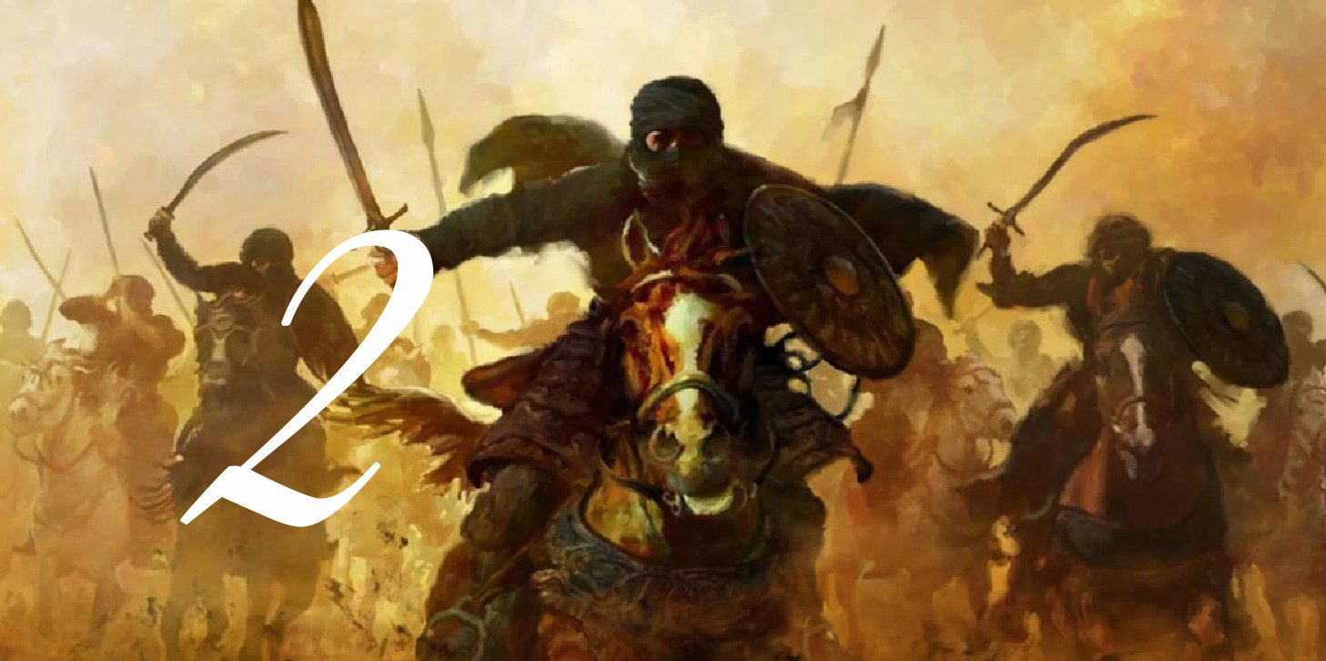
The wound received in Siffin
It was reported by Muhi al-Deen al-Arbli that a man
was in the presence of himself and his father. That man fell asleep and his turban fell off, exposing a large wound on his forehead. Al-Arbli asked him about the story of the wound, to which the man responded it was from the Battle of Siffin.
Al-Arbli asked: "how is that so when the Battle of
Siffin happened a long time ago?"
The man said: "One day, I was traveling to Egypt and 1
was accompanied by a man from Gaza. While we were
traveling, we discussed the Battle of Siffin. The man from Gaza said:
"If I were in the days of the Battle of Siffin, I would have raised my sword against Ali and his men."
I said: "if I were present in the days of the Battle of Siffin, I would have raised my sword against Muawiya and his men. Here we are, you are on the side of Muawiya
(la), and I am on the side of Ali (alayhe alsalam)."
So we fought a lengthy battle until I couldn't feel
anything that happened to me. While I was unconscious from my wound, a man came and woke me up with the edge of his spear. I opened my eyes and I saw him coming to my aid, cleaning the wound which felt painful. He told me to wait a little, he left then came back and had the decapitated head of my enemy with him. He said to me:
"This is the head of your enemy. You supported us so we supported you; Allah (swt) will support everyone who supports Him."
I asked: "Who are you?"
He said: "I am so and so, son of so and so (meaning, Sahib al-Amr Imam al-Mahdi). If anyone asks you about your wound, tell them you received it in Siffin."

The Pomegranate
Photo

Al-Majal allah taala farajaho alshariflisi, may God have mercy on him, narrated on
the authority of some of the honorable, trustworthy and well-known people, he said: Some of those I trust told me, who narrates it from someone he trusts and compliments him, that he said:
When the land of Bahrain was under the jurisdiction of
the Europeans, they appointed a Muslim to be in charge of it, so that he would be called upon to reconstruct it and set right the condition of its people. This governor was one of the Nawasib, and he had a minister who was more powerful than him. When he was on some days, the minister entered the governor with a pomegranate in his hand, and the governor gave it to him, and it was written
16
on it: (There is no Lord but Allah, Muhammad is the Messenger of Allah, Abu Bakr, Omar, Othman and Ali are the successors of the Messenger of God).
So the governor contemplated and saw the writing
from the origin of the pomegranate, so that it was not possible for it to be made by humans, so he was surprised by that and said to the minister: This is a clear sign, and a strong argument, to invalidate the doctrine of the Rafidah, so what do you think about the people of Bahrain?
He said to him: May God give you health. These are a group of fanatics, they deny the proofs, and you should bring them and show them this pomegranate.
If they convert to our madhhab, you will have the greatest rewards. And if they refuse anything but to stand on their misguidance, then give them the choice between
three:
Either they pay the tribute while they are humble, or they give an answer to this clear verse that they have no way of, or you kill their men, take their women and children, and take their money with booty.
So the governor approved his opinion, and called for the (Shi'i) scholars, the virtuous, the good, the noble and the righteous, from the (Shi'a) people of Bahrain, and he
brought them and showed them the pomegranates, and told them what he saw in them.
He informed if they did not come up with a satisfactory answer, the consequences would be:
Either killing them, seizing them, taking their money, or taking tribute on the face of young people like the infidels.
So the Shi'a were puzzled about it, and they were not able to answer, and their faces changed and their hearts trembled.
Their chiefs said: Give us three days, o governor, so that we may come to you with an answer that you will satisfy.
So they met in a council and postponed their opinion on that. They concluded that the solution is that they should choose ten people from from the righteous of Bahrain, so they did, then they chose three from the ten, and they said to one of the of the chosen three:
Go out tonight to the desert and worship God in it, and seek help from the Imam of our time, and God's argument against us, perhaps he will explain to you what is the way out of this horrid situation.
So he went out and spent the whole night worshiping, humbled, praying, crying, supplicating to God, and pleading with the Imam, peace be upon him, until morning
came and he did not see anything.
So they brought another of three people, and he was a pious and virtuous person whose name was Muhammad bin Isa, he went out the third night barefoot and bareheaded into the desert and it was a dark night, so he called and cried, and begged God Almighty to save these believers and relieve them from this calamity from them and seek help from the master of the time.
At the end of the night, a man was addressing him and saying: (0 Muhammad bin Isa, why do I see you in this condition, and why did you go out into this wilderness?)
He said to him:
O man, leave me, for I have come out for a great matter and grave situation, I do not mention it except to my Imam,
and I do not complain about it except to someone who is able to relieve it from me.
He said: (0 Muhammad bin Isa! I am the master of the time, so mention your need)
Mohammed said: If you are him, then you know my story and you do not need me to explain it to you.
He said to him: (yes, I came out when the matter of the pomegranate came to you, what was written on it, and what the governor promised you with.
Mohammed said: When I heard that, I went to him and said to him: Yes, my master, you know what has befallen us, and you are our imam and our refuge and the one who is able to relieve it from us.
He, may God's prayers be upon him, said: "0 Muhammad bin Isa, the minister, may Allah curse him, has in his house a pomegranate tree. When that tree bore, he made something of clay in the shape of a pomegranate, and made it two halves, and wrote inside each half some of that writing, then put them on the pomegranate, and tightened them on it when it was small, and caused it to be in the way it was.
So if you go to the governor tomorrow, say to him: "1 brought you the answer, but I only give it in the minister's house".
So if you go to his house, look to your right, and you see a room in it, then say to the governor: "I will only answer you in that room", and the minister will refuse to
do so.
And you must insist on that desire, and not be satisfied with anything but that. If he accepts, then go up with him, and do not leave him alone to precede you.
If you enter the room, you see a window in which there is a white bag, so get up to it and take it and see in it that mud that he made for this trick, then put it in front of the governor and put the pomegranate in it so that the situation will be revealed to him clearly.
Also, O Muhammad bin Issa, tell the governor: We have another miracle, which is that this pomegranate contains nothing but ashes and smoke.
When Muhammad bin Isa heard that from the imam, he was very happy and so he kissed the hands of the imam, may God's prayers be upon him, and went to his family
with good tidings and happiness.
When they came in the morning, they went to the
governor, so Muhammad bin Issa did everything that the imam commanded, and everything the Imam told him appeared.
So the governor turned to Muhammad bin Issa and said to him: Who told you this? He said: The imam of our time, and the proof of God is upon us. He said: Who is your imam?
So he told him about the imams one by one until he reached the master of our time, may the blessings of God be upon them.
The governor said: Stretch out your hand, for I bear witness that there is no Lord but Allah and that Muhammad is His servant and Messenger, and that the Caliph after him is without separation, the Commander of the Faithful, Ali, peace be upon him.
The narrator said: This story is well-known among the people of Bahrain, and the tomb of Muhammad bin Isa is known to them for people to visit.

Imam Mehdi And Abbas ibn All
Photo

A wise shia scholar named Ayatollah Sayyid Murtadha Langaroudi once said:
"I was at Abu al-Fadel al-abbas's shrine doing my
pilgrimage. Suddenly someone behind me who was also doing his pilgrimage, said to his eminence:"o my uncle!" Then started a speech with eloquence. I was intrigued. So much that I left my pilgrimage unfinished, to understand what he is saying. Although I was devastated, I was still listening to his enchanting words while he was talking to
his eminence and crying at the same time. But all of a sudden, he vanished.

The soap man
Photo

Sheikh Ali Akbar al Nahawndi has mentioned that once
a believing man was working in a perfume store in Basra, one day two men came and were looking for siddr and Kaffur.
Their appearance looked different to the rest of the city's civilians. He asked them about their city and they refused to answer.
He insisted on asking them until he swore to them by the name of raswul Allah to answer him.
They answered him immediately "we are from the close companions of sahib al zaman ajal allah taala farajaho alsharif, and since one of
our men has passed away the imam has asked us to buy Siddr and Kaffur from you"
The store man said once I heard this I started eagerly requesting them to take me with them and they replied the condition is up to the permission of the imam and since
we haven't got his permission we can't fulfill your request".
1 (the store man) said "them take me with you to ask for the permission of the imam, if he accepts I will stay and if he rejects I will return" They refused to take me but I kept asking them until they allowed me to go.
I closed my shop and I followed them until we reached a coast.
These two men didn't need anything to use for crossing the water as they used their own feet to walk on the water.
I was amazed not knowing what to do until they said to me "don't be scared, and ask Allah by the right of the Hujjah to protect you and then walk with us"
I did what they told me and I walked on the water.
The clouds started to gather while i was walking and it
started to rain, I remembered my soap (that he made) and how I left it outside uncovered for the sun.
The moment my attention went somewhere else my
feet started going down in the water and I tried to swim to protect myself, but the two men stopped and protected me and they said "Repent from what has caused you to be drowned in and renew your oath"
I repented and renewed my oath, and i was able to
walk with them. When we arrived to the coast, I saw a tent in the middle of the mainland; illuminating its surroundings. The two men said to me; the final destination is in this tent. We got closer to the tent, and one of them went in to ask for the imams permission. I was hearing their conversation and I heard the imam telling him "send him back he's a soapy person"
The moment i heard that i started to contemplate upon
the statement of imam and i realised that i lack decency for meeting the beloved as long as i am attached to the dirt of this world.

Imam Mehdi and al- Hurr al-Ameli
Photo

al-Hurr al-Ameli the author of the book "Wasa'il al- Shi'a" has mentioned in his book "Ithbat al Hidaya Bil Nusus wal Mu'jizat" the following:
I was 10 years old or so and I became very ill, the
people all gathered around me and cried intensely. They were prepared for my funeral and were certain about my death on that night.
On that night I saw the prophet, and the twelve Imams
(alayhe alsalam) while I was half asleep and half awake. I greeted them and shook their hands one after the other. After that a
conversation between me and Imam al-Sadiq took place. He prayed for me
Then when I greeted al-Sahib (Imam al-Mahdi) I shake his hand and started crying and said:
My master I am worried that I will die because of this illness and I haven't had enough of seeking knowledge. He (alayhe alsalam) replied: "Don't worry, you will not die in this illness but rather Allah will cure you and you will live a long life".
He then gave me a drink with his hand and I drank it. I was then cured and woke up. My family and the people were all surprised and I didn't tell them about what I saw
until a few days later.

Look at how my Shi'aS
Photo
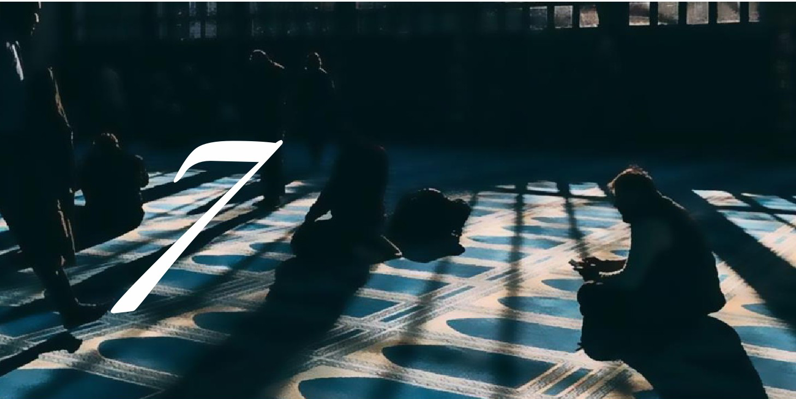
heikh Ahmed Mujtahidi has narrated the following:
One day during my days of studying in the holy city of Najal allah taala farajaho alsharifaf after praying the congregational prayer behind Ayatollah Madani I saw him crying severely and his shoulders were shaking from the intense crying, I went near him and I said, "My apologizes, did something terrible happened to you to cause you to cry in this way.
He replied: "For a moment, I saw the imam of our time (ajal allah taala farajaho alsharif) and he pointed at the people and said
Sayed Madani, look at how my Shi'a rush to their interests and none of them pray for my reappearance as if I'm not their absent Imam".
And that's why I'm crying...

Abu Rajal allah taala farajaho alsharifeh
Photo

The ruler in Al-Hilla was a person called Marjan Al- Sagheer, so it was reported to him that a person called Abu Rajal allah taala farajaho alsharifeh was cursing the Companions, so he brought him and ordered him to be brutally beaten all over his body.
To the extent that they hit his face, and his folds fell out, and they pulled out his tongue, and put an iron obelisk in it. They also pierced his nose, and put in it a band of hair, and tightened a rope in it, and handed it to a group of his companions and ordered them to go around the alleys of Hilla with it where the beatings took place from all sides, until he fell to the ground and saw death.
The governor was informed of this (how Abu Rajal allah taala farajaho alsharifeh was tortured brutally), and he ordered that he (Abu Rajal allah taala farajaho alsharifeh) be killed.
The attendees said: "He is an old man, and he has had enough for him, and he is dead for what he is, so leave him while he dies."
His face and tongue were swollen, and no one doubted that he (Abu Rajal allah taala farajaho alsharifeh) would die that night.
So, as from the next day, the people went to him.
To their shock, they saw that he (Abu Rajal allah taala farajaho alsharifeh) was standing and praying in the most perfect condition, and his folds that had fallen off returned to the way they were,
and his wounds healed, and no trace of them remained, and the wounds were removed from his face.
The people were amazed at his condition and asked him about his condition, and he said: "I saw death, and 1 did not have a tongue left to ask God Almighty for it. So I
used to ask Him with my heart and I pleaded with my master, Sahib al-Zaman (Imam Mahdi), peace be upon him."
So when the night came upon me, the house was filled with light, and behold, my master, the owner of the time, placed his honorable hand on my face and said to me: "Go out and toil on your children, for God has healed you. So I returned (to the good state) which you can see."
And Sheikh Shams al-Din Muhammad ibn Qaroon who mentioned the story - said:
And I swear by God Almighty that this Abu Rajal allah taala farajaho alsharifeh was very weak (in health), weak in structure, yellow in color, with a disfigured face and trimmed beard.
I always entered the bathroom in which he was in and I always saw him in this condition and this form.
When I became one of those who entered upon him (when we expected him to die). I saw him as his strength increased and his stature was erected, his beard grew long,
and his face reddened, and he returned as if he was twenty years old again and he stayed in that condition until death overtook him.
And when this news spread and became known the ruler ordered his presence.
He (ruler) had brought him (Abu Rajal allah taala farajaho alsharifeh) to his presence and he had seen him yesterday in that (sick) condition.
But now, he became the opposite of his condition, as the ruler did not see any trace of his wounds and his folds have returned. The ruler was in great terror in that.
Abu Rajal allah taala farajaho alsharifeh continued sitting in the Maqam of the Imam, peace be upon him, in Hilla, with his back facing the honorable qiblah, so after that he began to sit and face it,
and returned to be kind to the people of Hilla, to forgive their wrongdoers, and be kind to their benefactors until he died.

The Duaa of Al-Alawi Al-Masri
Photo

Muhammad bin Ali Al-Alawi Al-Husseini used to live in Egypt, and he said:
I was attacked by a great matter and severe anxiety from the governor of Egypt, so I feared for myself from him.
He had reported me to Ahmad ibn Tulun (ruler of the dynasty), so I left Egypt and became a pilgrim traveling from the Hijaz to Iraq, so I went to shrine of my master Abi Abdullah Al-Hussein bin Ali (may God's blessings be upon them both) and sought refuge in him and in his grave and sought refuge with him from the tyranny of whom I feared.
And I stayed in the shrine for fifteen days, praying and supplicating day and night.
Then Sahib al-Zaman appeared to me while I was between the sleeping and the awake. He said: "Al-Hussein says o' my son, are you scared of so and so"? I said: "Yes,
he wanted me to perish, so I resorted to my master (peace be upon him) to complain to him of the terrible things he wanted to do to me. He said: Would you not invite God, your Lord and the Lord of your forefathers, with the supplications that the foregoing prophets (peace be upon them) called for when they were in distress, so God
revealed that to them. I said: "With what do I pray to him"?
He said: "If it is the night of Friday, then take a bath and perform the night prayer, and if you prostrate the prostration of gratefulness, you supplicate with this supplication while you are blessed on your knees." So he mentioned to me a supplication and I saw him at that time coming to me while I was between sleeping and awake.
He used to come to me five consecutive nights, repeating this saying and supplication to me until 1 memorized it and he stopped coming to me on Friday nights.
Then he (peace be upon him) came to me on a Saturday night and said to me: your supplication has been answered, O Muhammad, and your enemy has been killed
when you have finished supplicating against the one who reported you to the ruler.
He said:
So when I woke up, I said goodbye to my master and left heading to Egypt.
So when I reached Jordan while heading to Egypt, I saw a man who was amongst my neighbors in Egypt who was a believer, so he told me that your opponent was arrested by Ahmed bin Tulun, who ordered him to be slaughtered from the back of his neck and thrown into the Nile.
And that was what a group of our Shiite family and brothers told me which was what reached them when I finished praying, as my master (may God bless him and
grant him peace) told me.
The supplication that the imam taught him is called:
(The Duaa of Al-Alawi Al-Masri) and it is one of the most important supplications for salvation from the enemy.

A book Written by Imam Mahdi
Photo

al-Shaheed al-Qadhi al-Tustari said:
One of the opposers wrote a book replying to the Imamiya (Twelver Shi'a), this book was read front of crowds of people, and it would deviate them through its allurement, and he wouldn't give the book to anyone out of fear that it would fall in the hands of the Shi'a and they would reply to it, the Late Allamah al-Hilli tried to get the book ever since he heard about it.
He then found the strategy in being a student under that person so that he can acquit himself from the accusation that he is an Imami.
He requested for the described book when he couldn't reply, he said: "I will give you the book but I vowed to not leave it with someone for more than one night, so the
Allamah seized the opportunity and took it to his house so that he can make a copy of what he possibly can from it in that one night.
When midnight came around and he was busy with writing he fell asleep.
Then our master Imam al-Hujjah (alayhe alsalam) entered his dream and said: "Leave the matter of the writing to me and sleep, so he did that, and when he woke up he saw the copy
of the book fully completed by the generosity of Imam al- Hujjah (ajal allah taala farajaho alshariftfs).

A lost man in the desert
Photo

Sayyed Hassan b. Hamza, a big Shia scholar narrates from a righteous man that:
"Once he exited his house to do his Hajal allah taala farajaho alsharif obligation, that year the heat stroke was common and illness was contagious. On the way, he was neglected and left behind
by the caravan. After a while he became thirsty, and he fainted in the hot desert. He was about to pass out until he heard a horse neigh. When he opened his eyes, he saw a handsome man with a distinctive smell, riding the horse with a bottle of water in his hand. He came down and gave him the bottle. It was the sweetest and coolest water he has ever drank. He asked him: "Who are you?" He replied:
"I am the authority of Allah upon his servants, I am the authority of Allah on earth, I am the son of Hassan, son of
Ali, son of Mohammad, son of Ali, son of Musa, son of Jaafar, son of Mohammad, son of Ali, son of Husain, son of Ali, son of Abi Taleb (alayhe alsalam)"
When he found out who he really was, he told him:
"Close your eyes." And he obeyed him and then he told him to open it and he obeyed once more. As soon as he opened his eyes, he saw himself beside the caravan and his eminence was nowhere to be seen.

Imam Mahdi's advice to Sayyid Muhammed Taqi al- Musawi al-Isfahani
Photo
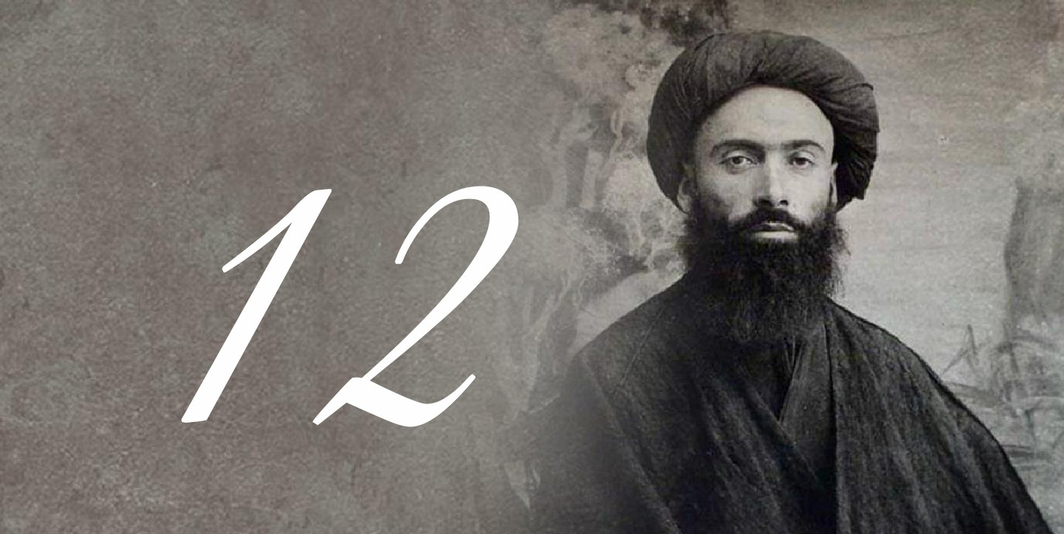
On a blessed night, Ayatullah Sayyid Muhammed Taqi al-Musawi al-Isfahani (rahmat allah alayh) had the honor to meet his master Sahib al-Asr Imam al-Mahdi (ajal allah taala farajaho alshariftfs) in his dream.
Sayyid Muhammed Taqi al-Isfahani asked the Imam
(ajal allah taala farajaho alshariftfs): "What do I do to get closer to you?"
Imam al-Mahdi (ajal allah taala farajaho alshariftfs) responds by saying: "Make your actions like the actions of the Imam of your time".
What Ayatullah Sayyid Muhammed Taqi al-Isfahani (rahmat allah alayh) understood from the Imam's reply was that if we were to do an action, we should ask ourselves, did our Imam do this action?
He then said to the Imam (ajal allah taala farajaho alshariftfs): "That is what we hope, so with what can I achieve that?"
The Imam (ajal allah taala farajaho alshariftfs) said: "sincerity in the actions"
After Sayyid Muhammed Taqi al-Isfahani's short but
meaningful conversation with Imam al-Mahdi (ajal allah taala farajaho alshariftfs) he understood after critically breaking down and deeply studying the conversation with the Imam (ajal allah taala farajaho alshariftfs) that it is
mandatory for the actions of the follower of the Ahlulbayt to be dependent on the actions of his Imam (ajal allah taala farajaho alshariftfs).

Grand Ayatullah Mar'ashi and Imam al-Mahdi (ajal allah taala farajaho alsharif)
Photo
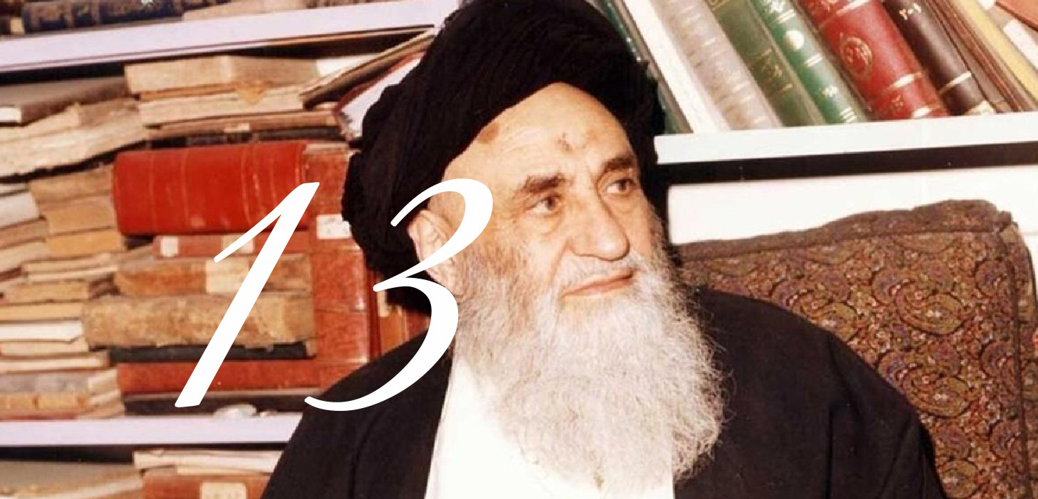
It is narrated that the Marjaa' Sayyid Shihab al-Deen al-Mar'ashi al-Najal allah taala farajaho alsharifafi said:
I took it upon myself to go walking on foot to Masjid al- Sahla forty times on every wednesday night from each week with the intention of being rewarded with the blessed meeting of Imam al-Hujjah (ajal allah taala farajaho alshariftfs), I stayed persistent on this for 35 or 36 nights.
That time, my departure from Najal allah taala farajaho alsharifaf to Masjid al-Sahla was delayed, It was raining, and the sky was cloudy, and there was a trench near Masjid al-Sahla, so when I reached that trench in that dark atmosphere I felt fear overcoming me, and my fear was from the bandits and thieves. I was in that thought when I heard footsteps behind me, so my
panic and fear increased, so I turned around and witnessed an Arab man in the attire of the bedouins, he got closer towards and greeted me in a fluent tongue and said:
"Salamun Alaykum O' Sayyid!"
The fear and panic in me vanished completely, and 1 felt tranquil and calm, and I was surprised at how that person knew I was a Sayyid even though the atmosphere
was extremely dark. Anyways, we walked together and talked and he asked me: "Where are you going?" I answered: "To Masjid al-Sahla."
He said: "For what reason?" I answered: to be honored with the visitation of Wali al-Asr (ajal allah taala farajaho alshariftfs).
Then we walked for a short while until we reached Masjid Zayd bin Suhan which is a small masjid that is near Masjid al-Sahla, so we entered the masjid and prayed,
then that man started reciting duaa, so it was as if the walls and stones were supplicating with him. So then I felt a strange change inside of me that I can't explain.
We then sat down in the middle of the masjid in the maqam of Imam al-Sadiq (alayhe alsalam), I asked him: "Would you like tea or coffee or tobacco so that I can prepare it for
you?" He replied with a complete answer saying: "Those things have no benefit to them, and we have nothing to do with it."
What he said had such a great effect on the depth of my being that everytime I remember it my organs shake.
The meeting took two hours, and we had a conversation during that time. I will mention some of the important matters mentioned in the conversation:
1- We spoke about the matter of Istikhara.
2- He emphasized on reading those verses after the
five daily prayers: After Fajal allah taala farajaho alsharifr Surah yasin, after Dhuhr Surah al-Naba', after Asr Surah Nuh, after Maghrib Surah al-Waqi'a and after Isha Surah al-Mulk.
3-He emphasized on praying two rakat between Maghrib and Isha, reading any Surah of your liking in the first raka after Surah al-Hamd, and reading Surah al- Waqi'a in the second raka after Surah al-Hamd.
4- He emphasized on reading this duaa after the five daily prayers: O' Allah relieve me of the worries and the anxieties and the loneliness of the chest.
5- He emphasized on reading this duaa after performing raku' in the five daily prayers, especially in the last raka': ' Allah send your blessings upon Muhammed
and the progeny of Muhammed and have mercy on our inabilities, and help us by their right.
6- He emphasized on reading this duaa in Qunoot: O' Allah send your blessings upon Muhammed and his
progeny. O' Allah I ask by the right of Fatima, and her father, and her husband, and descendants, and by the secret that is special to her, to send your blessings upon
Muhammed and the progeny of Muhammed, and to do to me what is worthy of you, and don't do to me what is worthy of myself.
7- He made a high exceptional praise about the book (Shara'i al-Islam) by the late al-Muhaqiq al-Hilli, and he said in regards to it: it all corresponds to reality, except for a few issues.
8-He emphasized on reading the Quran and gifting its rewards to the Shi'a who have no one in this world.
9- He emphasized on al-Tahnuk which is unloosing a part of the turban under the hanak like what the scholars of the Arabs do, he said: "This is what is mentioned in the
Laws."
10- He emphasized on the visitation of the Master of the Martyrs (alayhe alsalam).
11- He prayed for me and said: "May Allah make you amongst the servants of the religion."
I asked him: "I don't know, will the outcome of my affairs be good? And is the owner of the holy laws (Imam Mahdi) pleased with me?"
He answered: "The outcome of your affairs are good, and your endeavors are appreciated, and your face is enlightened."
I then asked: "I don't know, are my father, my teachers, and those who have a right upon me pleased with me?"
He said: "All of them are pleased with you, and they pray for you."
Then I asked him to pray for me so that I am successful in authorship and compilation, so he prayed for me in regards to that.
Sayyid al-Mar'ashi said: "I had to leave the masjid so I headed towards the sink", and midway a thought came to my mind: "What night is this night? And who is this Arab man who holds those merits and virtues? He might be the Imam!" As soon as this thought crossed my mind I wanted to go back. I looked back and I didn't see that person, and no one was present in the masjid. There I realized that I had seen the Imam, but I was unaware of that. I started weeping and crying until the morning, looking all over the masjid like a crazy man, and like a lover with a broken heart looking for his beloved one after a long period of time.

Sheikh al-Ansari reaches out to Imam al-Mahdi (ajal allah taala farajaho alsharif)
Photo
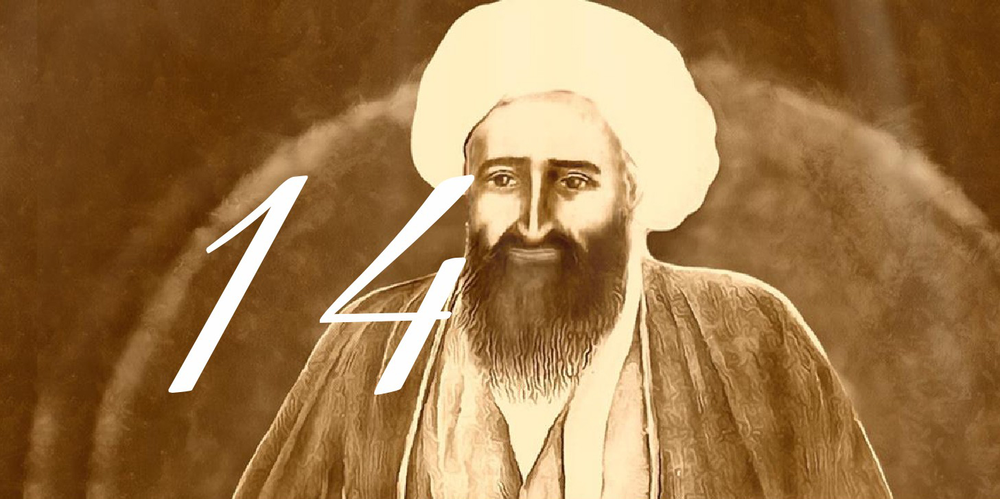
One of the scholars of Islam whose vast knowledge of the religion has echoed the world is Sheikh Murtadha al- Ansari (rahmat allah alayh). He was a descendent of Jabber ibn Abdullah al- Ansari, a loyal companion of Prophet Muhammed (saww).
al-Muhadith al-Nouri narrates in his book Khatameh al- Mustadrak that:
Allah has blessed Abdullah with a man from his dynasty that has dedicated himself to research and worship for the sake of Islam. During the time of his leadership over the Shia community, he was a worthy servant for Imam al-Mahdi and remembered the Imam throughout his lifespan one of his students narrates that:
"It was midnight in Karbala, I exited my home while it as dark and muddy outside. I brought a torch with me to light the way. I saw someone in the distance. When he
approached me, I recognized that he was Sheikh Murtadha al-Ansari. When I saw him, it got me thinking? Why is the Sheikh in the dark and muddy street at this time of the night? I followed him slowly and cautiously, fearing that someone might ambush me from behind. He stood up against a house & started reading Ziarat al-Jamaa with distinctive attention. Then he entered the house and I lost sight, but I could still hear him talking to someone. A few hours later, I saw him in the shrine of Imam Husain. I approached and asked him about the events of last night. After insisting on getting an answer, he said:
"Sometimes I reach out to imam al-Mahdi (ajal allah taala farajaho alsharif), go to his home, read the ziarat, enter (that you cannot), ask the Imam and exit"
After he told me that he made me promise not to tell this to anyone until after he passes away.

Ask the Imam and he will aid you
Photo

Sheikh Mohammad Ansari al-says:
“During my trip to Samarra, I considered visiting the holy shrines. It was past sundown and I hadn't prayed my obligated prayers. Next to the shrine, I saw a mosque that was performing congregational prayers. But little did I know that the Imam of the prayer and the others praying behind him were Sunni. So, I entered the mosque with my son and I did my prayers in a corner. I had to prostrate on dust and because of that, when the congregation ended, the people that were in the mosque looked at me with
anger and began swearing at us. At that moment I knew that I had made a mistake. Because when everybody left, suddenly, the light went out and the door was locked. No matter how much I called for help there was no hope, my son and I were frightened, I thought our death was inevitable. So, I began crying and complaining to Imam al- Mahdi (ajal allah taala farajaho alsharif) and pleading to Allah (swt) to aid us through the Imam, suddenly my son said:
"Father! I have found a way. A pillar next to the entrance that is part of the wall is higher than the surface."
I looked at it and he was right. The gap was so significant that we could easily escape. So, we crawled from underneath the pillar & as soon as we escaped, the
pillar returned to its original position and sealed the gap once again. The next day, I came back and saw that there was no sign of the gap that was made.

Sayyid al-Qazwini pleads to the Imam for help
Photo
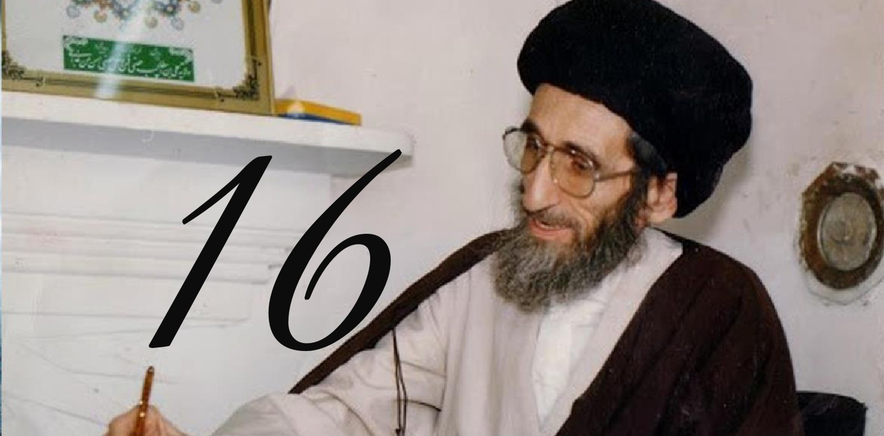
A story about, Sayyid Muhammad Kadhim al-Qazwini (rahmat allah alayh), this incident happened in 1392 AH (hijri calendar) narrated from Ayatullah al-Shaheed Sayyid Muhammed
Ridha al-Shirazi (rahmat allah alayh):
My father (Sayyid Muhammed al-Shirazi) made Sayyid M. Kadhim al-Qazwini his deputy in Karbala after his migration. One of the things that Sayyid Muhammad
Kadhim was appointed to do was taking care of the monthly payments to the hawza students.
During this time, he told me a story which generally can be seen as nice. He says on one of the Friday nights - this is when monthly payments should be distributed to
the students. However, the money was not given.
Now Even if hawza students look at life with asceticism, they still need their payments because for example - their wives and children will need food to eat.
Sayyid al-Qazwini said: I thought about getting a loan, but no one was willing to loan me.
However, I cannot tell the students that there is no money to pay them - as it is an obligation we are bound to them.
Sayyid M. Ridha al-Shirazi (rahmat allah alayh) says: I remember when Sayyid Kadhim was arrested in Saddam Iraq during that time with serious charges. A scholar and man of religion, appointee of a Marjaa', distributing money to students - this is a charge one can never be saved from.
One of his sons when we (Shirazi family were in Kuwait), says everyday he would write a letter to Imam al-Mahdi.
Him and I would write letters to the Imam and throw the letter into the sea. Allah then saved Sayyid Kadhim and he lived a long life after that.
Sayyid M. Kadhim said in the letter concerning the hawza students: "O' Imam, if the story of (scholar) Bahr-ul Uloom is correct. That he was in Mecca, needed money,
and did tawassul to you and you gave him that money.
If that story is correct, then I am now facing the same situation as Bahr al-Uloom. So I ask you O' Imam to send me such money."
He wrote that letter, and went to Imam Husayn shrine, and slid it into the mausoleum.
He woke up in the morning and someone knocked on the door and gave him the amount. It was 1000 Iraqi dinars and back then, this was a very big amount.
This person was a merchant from Baghdad who came after Fajal allah taala farajaho alsharifr prayer.
He was taken aback by this, thinking to himself "O Imam, you gave me this amount even before sunrise. You didn't wait until sunrise to give me the money".
Then the merchant noted this change of expression:
"Why have your facial expressions changed, Sayyid?"
So the merchant broke down crying at how the Imam made him a medium to answer a believer's prayers. That the Imam inspired this thought onto him.

The importance of sincerity
Photo
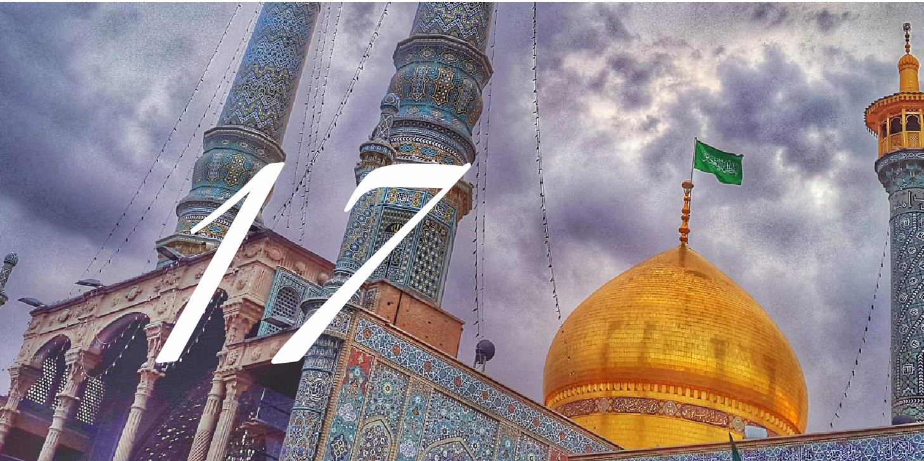
His Eminence Sheikh Ali Akbar Mahdi Poor who is trustworthy narrates that:
In his dream, he saw Imam al-Mahdi (a) going to his aunt Sayyida Masuma's Shrine (a).
I was told that the Imam wants to visit you in your library as there are many books of the mukhalifeen (opposers) and that he (a) hates and despises those cursed
books, and it is of your duty to throw them away from your library and house.
So he went as fast as he could and threw away all of the books from the mukhalifeen that were in his library.
They also told me to take out all the luxurious carpets from my house or place them upside down and not show the drawings on them.
So hence I discovered that the Imam (a) honors the one who has the guardianship/loyalty of the Ahlulbayt (peace be upon them), as well as having strong hatred for their enemies, and the servant must have a simple life, free from ornaments, arrogance, and so on.

Sheikh Muhammed Taha Najal allah taala farajaho alsharifaf and Imam al-Mahdi (ajal allah taala farajaho alsharif)
Photo
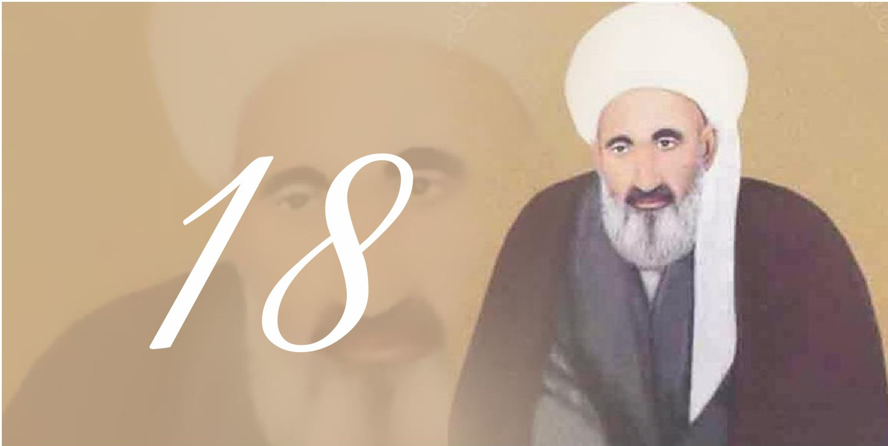
Sayyid Ja'far Bahr al-Uloom (rahmat allah alayh) narrates that:
He went to Sayyid Husayn Bahr al-Uloom house and there was an Indian man who claimed to be a Sadhu.
He claimed that he could answer any question through spiritual calculations.
So relatively people started asking him questions and he answered all of them with ease. Sayyid Husayn Bahr al- Uloom tells the man: "I will ask you a very difficult question that you can't answer, where is Imam al-Mahdi?" The man
does his calculations and repeats it multiple times, Sayyid Bahr al-Uloom told the man: "I told you, you can't find the answer to that question."
The Sadhu says: "I have the answer, do you all know a man by the name of Muhammed Taha Najal allah taala farajaho alsharifaf in the city of Najal allah taala farajaho alsharifaf?"
They all said yes. He told them that the Imam is currently there! They all left rushing to Sheikh Muhammed Taha Najal allah taala farajaho alsharifaf's home.
As they reached his home and before entering they witnessed a man with a pious look on his face who seems to be from amongst the bedouins leaving the Sheikh's
home.
When he saw them he said Salam Alaykum and continued walking. When the scholars entered Sheikh Muhammed Taha Najal allah taala farajaho alsharifaf's home they witnessed him severely crying and during that time the Sheikh lost his vision completely. He didn't know they entered until they said Salam to him. They asked him in regards to the reason
why he was crying.
The Sheikh says: "I lost an opportunity."
They asked what opportunity?
He said: "Three years ago it crossed my mind that we give fatwas to people and give them advice and fix their problems, are all those actions accepted by Allah and the
Ahlulbayt?
Then there was a day when I saw Imam Ali in my dream and he said: The answer to your question is with my son Imam al-Mahdi and I've been waiting for the answer
ever since.
I can't see but a man from the bedouins asked me a question then I answered, and he put out an argument on my answer then I tried to reply to his argument and he
made another argument on my reply!
Then when I tried to reply to his second argument he made a third argument on my second reply! Then he got up and put his hands on my shoulder and said O' Sheikh we
are pleased with you and left.
The Sheikh was shocked. How does this bedouin put an argument on a Marjaa's answer and put his hand on his shoulder? Then he remembered what Imam Ali said in his dream and realized that was Imam al-Mahdi.

Imam Ali refers a scholar to Imam Mahdi
Photo

One of the scholars that had the honor to meet Imam al-Mahdi (ajal allah taala farajaho alshariftf) and asked him questions is al-Muqaddas al-Ardebili (rahmat allah alayh) a noble scholar who had reached a high
level of piety and worship.
It's been written that whenever he faced problems in his life.
He reached out to the Commander of the Faithful and asked questions and his eminence would answer! One of his students, who was a known scholar at that time speaks
about the secrets of his teacher:
"One night I was strolling in the courtyard of Imam Ali (alayhe alsalam) shrine. Tired from studies, and suddenly in that spiritual atmosphere, I saw a shadow that was headed
towards the shrine while the doors were locked. He approached the doors and unlocked them one by one.
I followed him curiously until he stood in front of the shrine with dignity, pride, pledge, and loyalty.
I heard the response with my very own ears. Not long after, he exited and headed towards the Masjid al-Kufa.
I followed him curiously. He entered the sanctuary and returned towards the city. He reached the gates of Najal allah taala farajaho alsharifaf.
Sunrise was upon us and people were slowly rising from their slumber for morning prayers.
Suddenly I had to sneeze. I couldn't hold it much longer. And when I did, the man turned around. I recognized him. He was none other than my teacher al- Muqaddas al- Ardebili.
I greeted him and then said: "I was with you the entire night, from the shrine until this very moment.
Can you tell me who you were talking to?" He asked me to promise not to speak about it until after his death. And
then he said:" My son, sometimes there are situations in life that I'm incapable of solving.
So, I reach out to the Commander Imam Ali (alayhe alsalam).
But last night, I was referred to Imam al-Mahdi (ajal allah taala farajaho alsharif) who was at Masjid al-Kufa. He said that he will aid you in your problems.
So, I traveled there and asked from the Imam himself.

Contents
one glance could prevent you from seeing Imam al-
Mahdi .............7
The Pomegranate...... ....15
Imam Mehdi And Abbas ibn Ali ..........23
The soap man ........25
Imam Mehdi and al-Hurr al-Ameli ....29
Look at how my Shi'as................ 31
Abu Rajal allah taala farajaho alsharifeh ......33
The Duaa of Al-Alawi Al-Masri ............37
A book Written by Imam Mahdi .... 41
A lost man in the desert...........43
Imam Mahdi's advice to Sayyid Muhammed Taqi al- Musawi al-Isfahani .....45
Grand Ayatullah Mar'ashi and Imam al-Mahdi (ajal allah taala farajaho alsharif) .....47
Sheikh al-Ansari reaches out to Imam al-Mahdi (ajal allah taala farajaho alsharif).......53
Ask the Imam and he will aid you .... 55
Sayyid al-Qazwini pleads to the Imam for help ......57
The importance of sincerity ...61
Sheikh Muhammed Taha Najal allah taala farajaho alsharifaf and Imam al-Mahdi (ajal allah taala farajaho alsharif)................63
Imam Ali refers a scholar to Imam Mahdi....................67

ghaemiyeh.com

