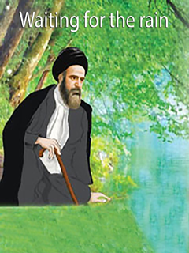

Waiting for the Rain


ghaemiyeh.com

فهرست مطالب
Point 4
a gift 4
Alley after alley of Eghlid 5
The bread of Imam al-Zaman (as) 7
Dua Rain 15
Shelter of Creation 25

Point
نام کتاب: Waiting for the Rain / پدیدآورندگان : جمعی از ارادتمندان و دلباختگان نجات بخش عالم بشریت حضرت بقیة الله الاعظم امام زمان عجل الله تعالی فرجه الشریف
the late Grand Ayatollah Agha Seyyed Mohammad Baqir Movahed Abtahi
ناشر: محب العترة الظاهرة علیهم السلام
تاریخ انتشار: ربیع الثانی ۱۴۴۲ ه.ق - پاییز ۱۳۹۹
زبان: انگلیسی
تعداد صفحات: 32 ص
موضوع: استغاثه به امام زمان
موضوع: دعای باران
موضوع: توبه و انابه

a gift
The text of the beautiful book (Waiting for the Rain) is a valuable and wonderful work. A Mahdavi gift to teenagers and young people….
Waiting for the Rain / پدیدآورندگان : جمعی از ارادتمندان و دلباختگان نجات بخش عالم بشریت حضرت بقیة الله الاعظم امام زمان عجل الله تعالی فرجه الشریف
ناشر: محب العترة الظاهرة علیهم السلام
تاریخ انتشار: ربیع الثانی ۱۴۴۲ ه.ق پاییز ۱۳۹۹
the late Grand Ayatollah Agha Seyyed Mohammad Baqir Movahed Abtahi

Alley after alley of Eghlid
In the name of God, the Beneficent, the Merciful
I passed through the back alleys of Eqlid, a city called the city of Imam Zaman.
There was peace and serenity in the faces of the people of that city, which could not be seen in many places.
Children were playing in the streets and the sound of their childish laughter broke the silence of the city.
It was close to noon. The fragrant smell of local bread filled the air.
As I was walking, I saw Agha Mohammadi, a teacher of Persian literature at our school, coming towards me with a basket full of hot, fresh bread.
I was very happy to see him. The teacher was calm and kind, he also taught us about religious books in our school.
He warmly offered me some hot bread from the basket!
I said: No, thank you! I just ate breakfast.
Agha Moallem, with a polite smile on his face, said in his Eqlidian sweet accent: "This bread is different from other breads! Please ... in the name of God!”
With a little surprise, I took the bread from them, thanked them and said: “How is this bread different from other breads?!”
image
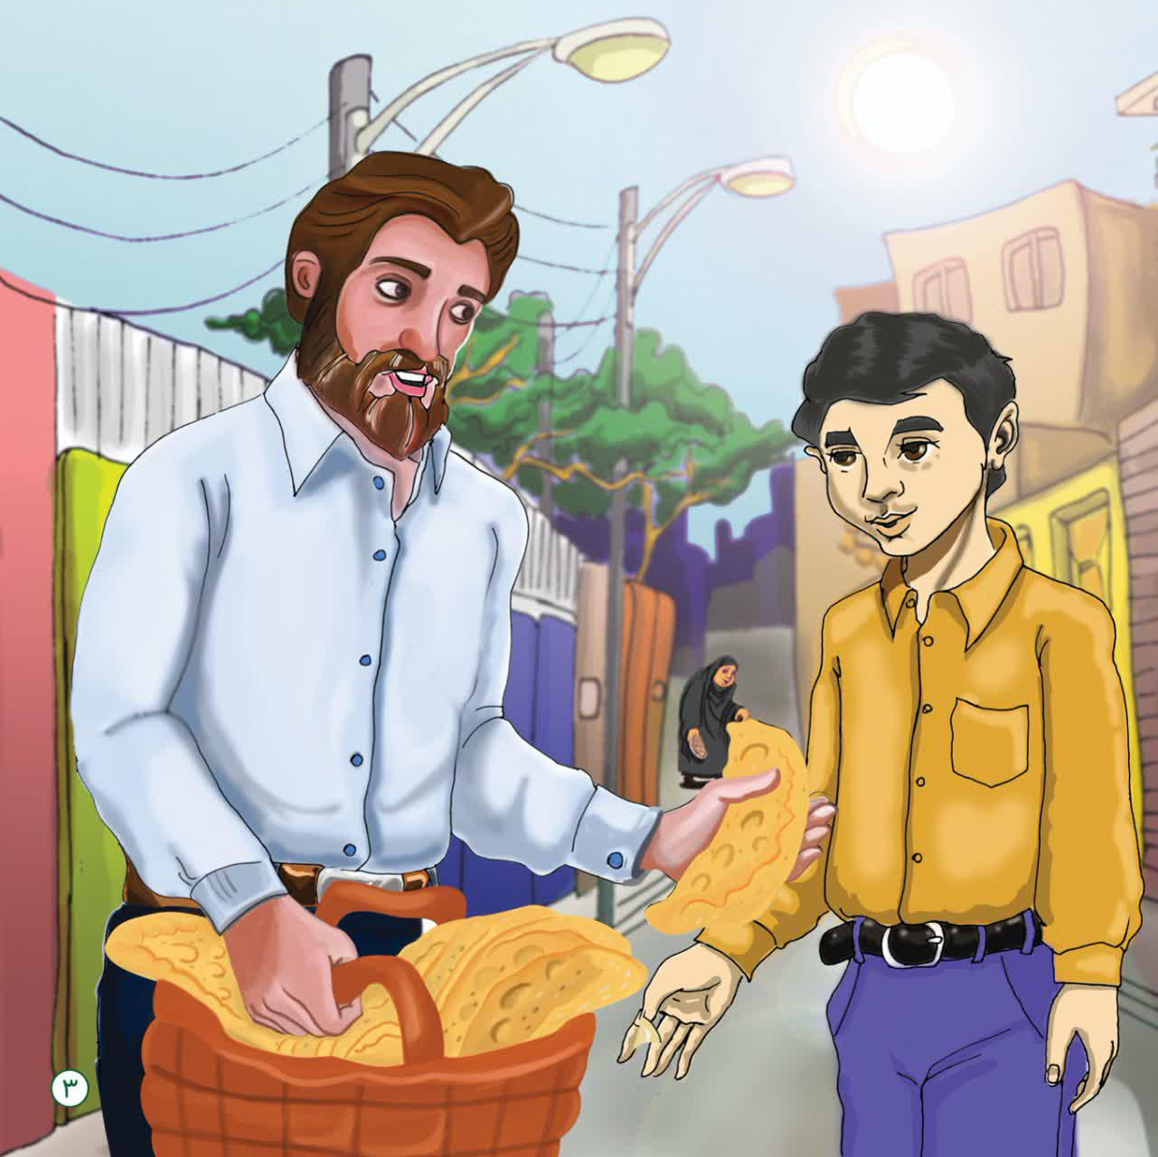

The bread of Imam al-Zaman (as)
Agha Moallem said: “This bread is Imam Zaman’s, and it is home baked for the wishes of Agha Imam Zaman’s safety;and we are distributing it among the people. You can come with us and we can distribute these breads together if you want.”
It was very interesting to me! I thought about it! Wow! Nun [bread] of Imam Zaman?!
It felt good! It was a worthwhile experience.
We followed Agha Moallem with a basket full of bread. We visited many houses. We even went to clinics.
When we gave the breads to the people with the help of Agha Moallem, we saw tears of joy in their eyes, how happy they were that the bread of the Imam of the time had become their day.
One wanted bread to cure his patient, the other for his pregnant daughter! And one for the blessing of his blood...
It was so sweet to me! In the alleys of Eqlid, where the name of Imam Zaman was everywhere, even the bread of Imam Zaman was enjoyed.
image
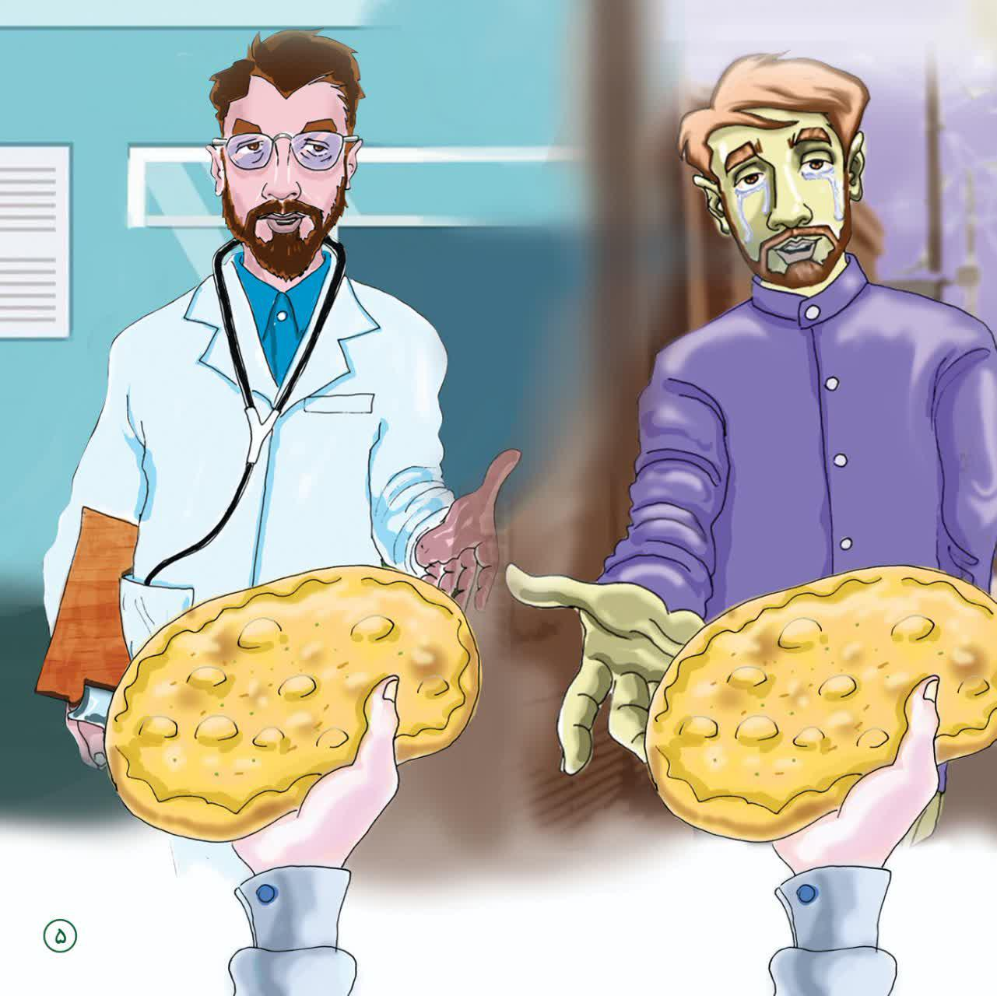
On the way, Agha Moallem was talking to me, and at one point in his speech, he said: “Do you remember that I was talking about the verse ‘O you who believe! Fear God and seek refuge in the means of nearness to Him’ in class?!”
I said: “Yes, teacher!”
He looked at me meaningfully and said: “God said: ‘If you want to talk to me, and come near to me, come with an intermediary, that intermediary is Imam Zaman whose bread you are distributing for his safety’s sake.’”
Hearing this, cold sweat settled on our foreheads!
I said: "Sir, I got closer to God now by doing this?!"
Agha Moallem said: “You are closer to God than you imagined!”
In my heart I thanked God! What a day today!
We reached the last house and I gave the bread of Imam Zaman to the trembling hands of a lonely old woman, she prayed for me a lot, put the bread on her head and thanked me.
image
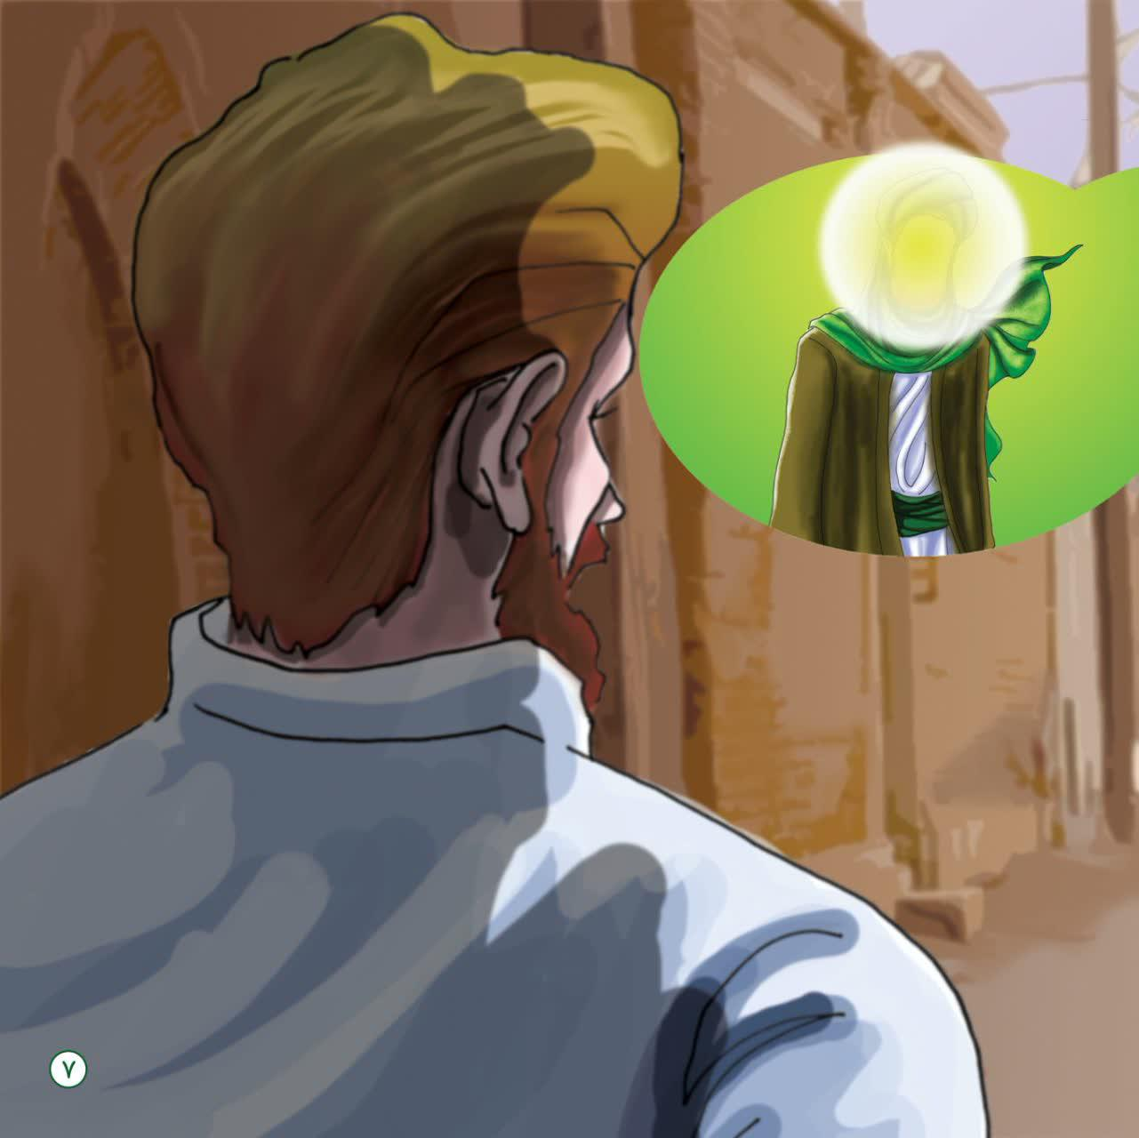
The work of distributing the bread was completed and the sound of the noon call to prayer could be heard from the Eqlid Grand Mosque.
Agha Moallem, who was drenched in sweat from the summer heat, said with his usual smile: “Well! Be accepted! Today you had the chance to do a great job for Imam Zaman! May the Imam of the Age help you in your studies and life!”
I was proud of what the teacher said.
Agha Moallem said: “I am going to the Grand Mosque for prayer! If you like, let's go together!”
I was very happy that after working for Imam Zaman we could go to the house of God and pray in congregation. We moved towards the mosque.
A cool breeze began to blow… I had a special feeling of vitality and calm.
We entered the Eqlid Imam Zaman Grand Mosque. What a magnificent mosque. There was a clear spring (where the water comes up naturally from the ground) inside the mosque! We went next to it and performed ablution. What a purity it had...!
The prayer started, and a large crowd had formed. The feeling of praying in the mosque was spectacular. Today's prayer was very different from previous prayers. I felt like God was paying more attention to me! Today, I came to the house of God tired (as a result) of sharing the bread of Imam al-Zaman. Wow, what a pleasure!
The congregational prayer ended. We recited the Dua of Faraj and got up.
After the prayer, the teacher called me and I came to him. He hugged me and said: “May your prayer be accepted,O soldier of Imam Zaman!”
image
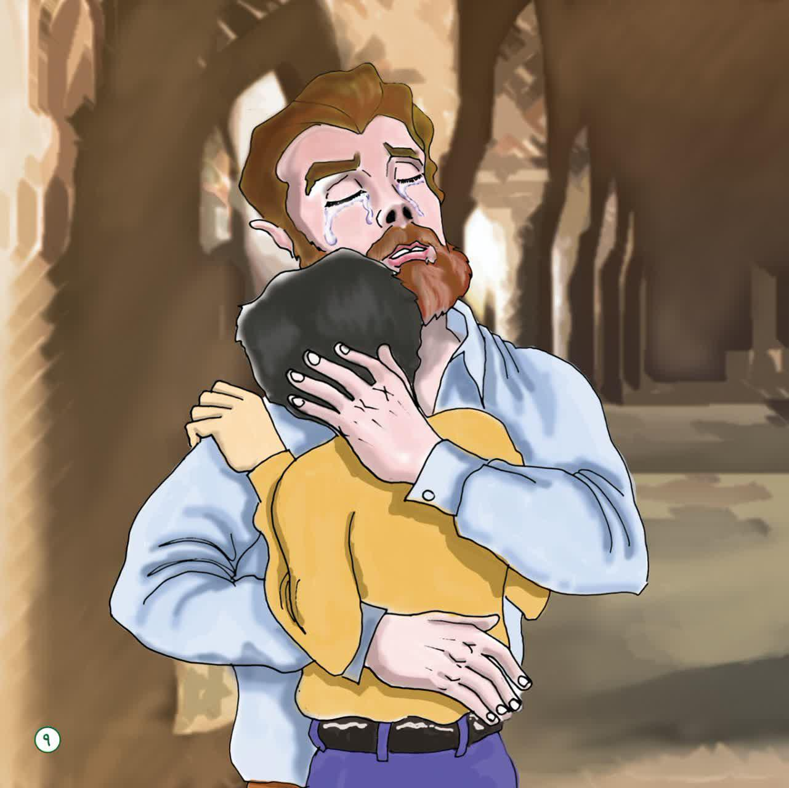
Agha Moallem said: “Your service to Imam Zaman today was your honor and not everyone can bring the name of Imam Zaman at their own discretion, let alone do something for him, Imam Zaman loves them in a different way! I also love the person whom Imam Zaman loves very much.
I was talking to Agha Moallem when Yahweh, the spiritless voice of a disturbed old farmer, caught our attention. The old man had raised his trembling hands to the sky after the prayer and was talking to God, saying that it had not rained for a long time! “Our land has dried up! Will you not have mercy on us?” He was complaining to God about the drought.
I looked at the teacher, I saw that his eyes were full of tears and his countenance was completely changed.
I asked: “Did something happen?!”
Agha Moallem, who could not stop crying, looked at me and said: “I just had a recollection of an episode of my adolescence taking place in this mosque, during a drought which affected not only my life but also the lives of many people of Eqlid of Imam Zaman and everyone remembers it!”
With this sentence, I was very eager to know what that memory was, and I said: “If you define that memory for me, I will be very happy and my spiritual thirst will be quenched today.”
image
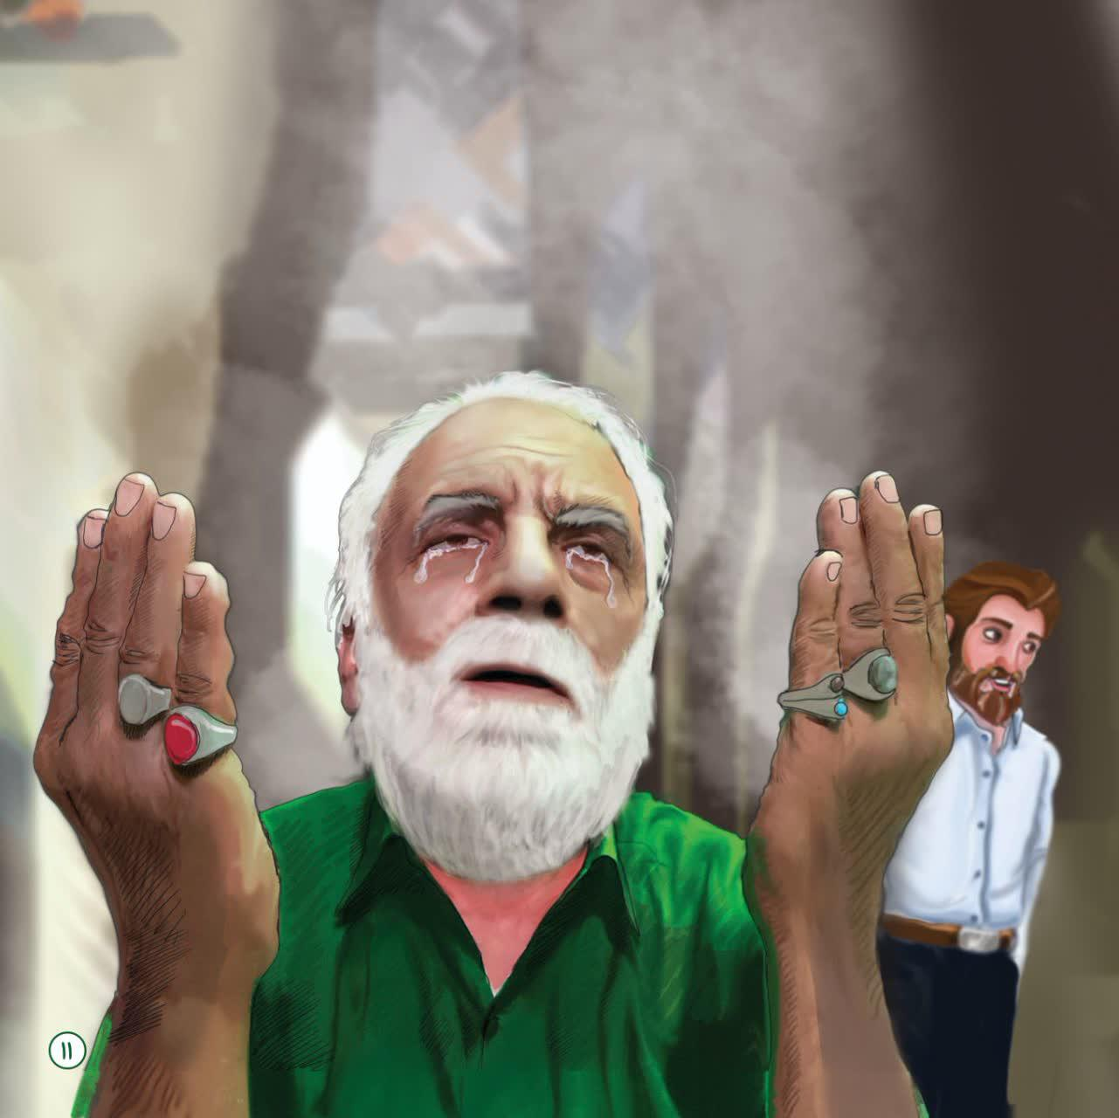
Agha Moallem, while wiping his eyes with a handkerchief, smiled and said: “Alright! I will tell you.”
We moved to the old pulpit of the Grand Mosque and sat next to it.
The teacher leaned on the pulpit.
He sighed and said softly:

Dua Rain
“It feels like it happened yesterday! I was going through my adolescence. Everyday my father used to take me to the Grand Mosque for prayer.
The Imam of the mosque was a gentleman, Sayyid Ziba, luminous and Jalil al-Qadri (eminent) that the people of Imam Zaman’s Eqlid used to touch the Imam for his greatness and compassion with all their being! He had much love for the Imam of the time. He had taught us how to bake bread and make vows for Imam al-Zaman, and the fact that all the back alleys of Eghlid are named after Imam al-Zaman is due to the blessings of that great Sayyid. From Aba saleh tunnel to the bath and the clinic, etc.
I said: “Is he the same Seyyed Abtahi who wrote "O! Abtahi's grandfather" on my father's truck?!”
The teacher smiled and said: “Well done! Yes! He was the late Grand Ayatollah Agha Seyyed Mohammad Baqir Movahed Abtahi.”
Agha Moallem continued his speech: “We used to come to the mosque every day and offer our prayers to his Imamate.
Prayer and supplication with Sayyid had its own enthusiasm and enlightenment!
image
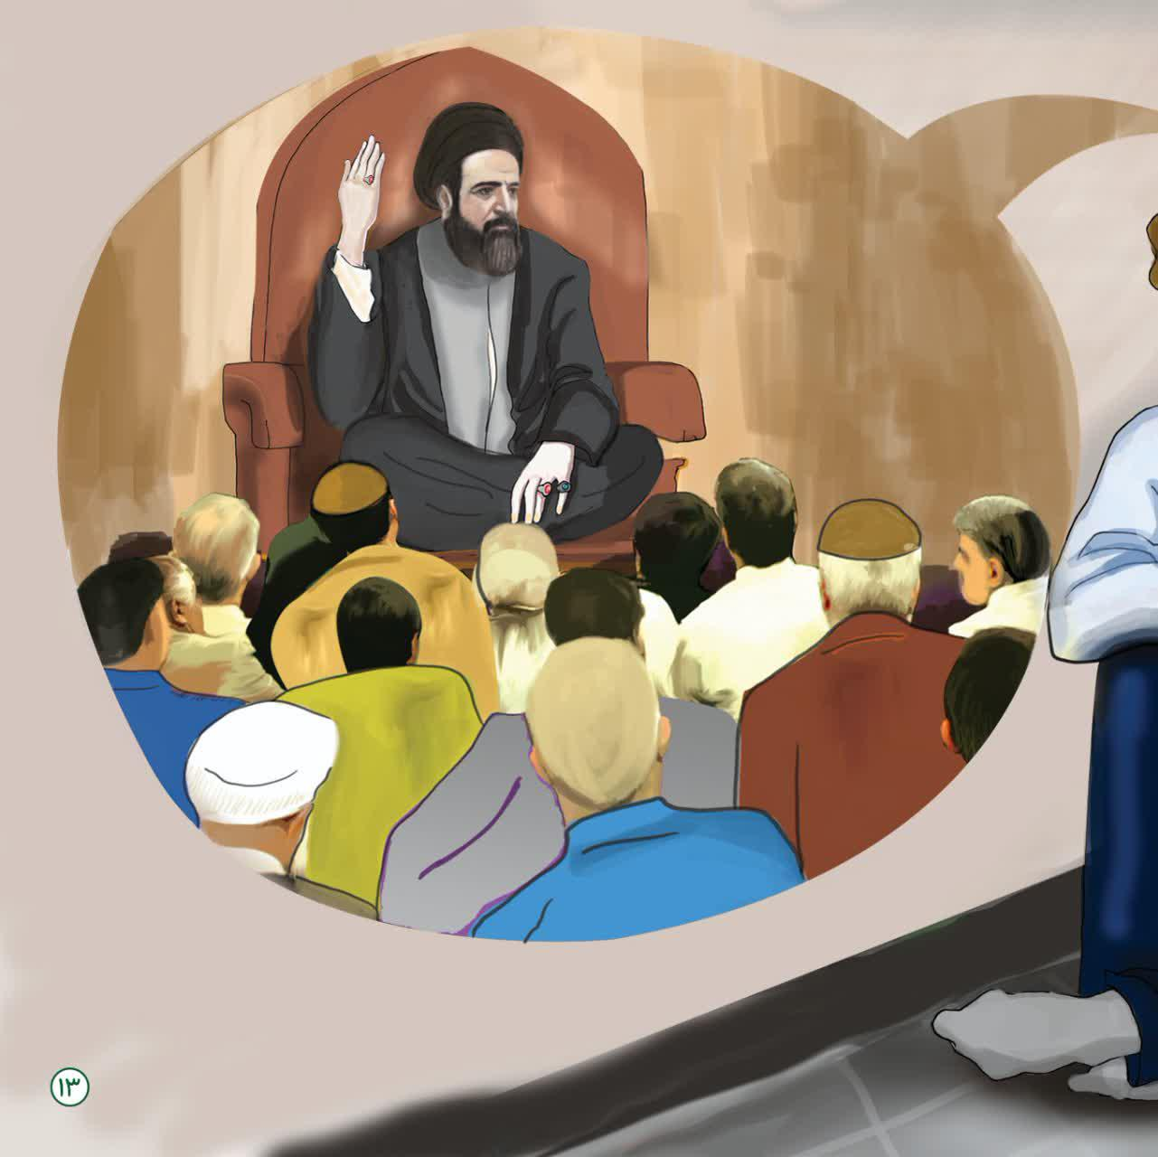
I remember one day after the prayers were over, they sat on a chair and talked, and I came a little closer to hear their voices more clearly. I approached and saw that, as always, they were saying soothing words with their beautiful Isfahani accent, and the tears in their eyes had soaked their virtues.”
Agha Abtahi said with a broken heart: “Gentlemen! Imam Zaman got no companion! He is very oppressed! Why don't you pray for Faraj of Imam Zaman, which is our own bliss? Why do you not pray in secret and privacy for his loneliness, why don't you read prayers for him?!”
It was very strange to me! I had never seen anyone talk so much about the ImamZaman!
It was as if Agha Abtahi had lost his father at that moment, and it was as if he did not feel any greater sorrow in this world than being away from the Imam Zaman!
A little later, he said: “Let us pray for the Faraj (reappearance) of the Imam of the Time!”
It was a very strange feeling. Everyone recited du’a of Faraj and he (Agha Abtahi) cried a lot! This was his daily work.
After the prayer, they leaned on their canes and waited to ask if anyone had any work or questions, and then went home.
image
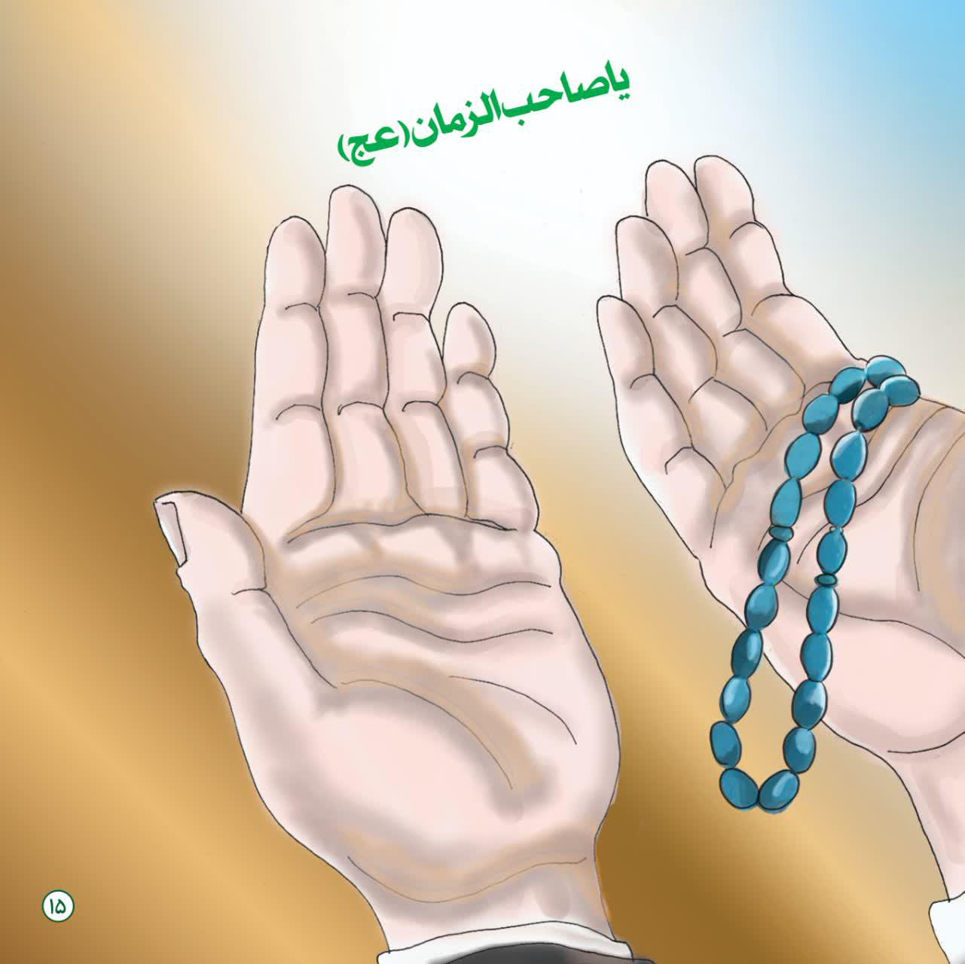
My father and I were sitting when we saw some old men dressed as shepherds, and farmers approached them and sat next to them.
One of the ranchers of the area came to Sayyid's service and kissed his face and cried and begged him in a trembling voice and said: “Agha Abtahi! We are very pensive! We are very upset! We are very sad!”
When he heard this sentence, the color of the face of the teacher turned red and he answered with concern: “Why are you so upset?! What happened?!”
The farmer, whose clothes were dusty and he seemed too old and exhausted because of the hardship and the problems of life visible on his face said in a shaky voice: “Son of Hazrat Zahra! Please help us! I swear, it has not rained for so long that there is no grass left for the sheep to eat, and because of the intensity of their hunger, they push back the soil around the roots of the grass with their hands, so that they can eat some of the roots; Pray that God will have mercy on us and bring down the rain of His mercy for these animals.”
While the weary farmer was speaking with a broken heart, whose face had been burned by the hot sun, he said in his local accent: " Agha Seyed! Drought has impacted our wives and children! I swear we have nothing to eat. Please ask God, maybe God will have mercy on us.”
The old man, who was crooked, slowly approached Seyed and said:
“Hazrat Agha! I heard from you that when Kufa went through a severe drought, the people took refuge in the Amir al-Mu'minin to do something. Hazrat then said: ‘Tell my Hussein to pray’ and the martyrs prayed and the rain came to Kufa and its land was watered! Agha Abtahi, you are the son of Imam Hosseini! Pray to Imam Hussein for rain!”
When Sayyid heard these words from the people of Eqlid of Imam Zaman, his eyes became like a bowl of blood, he lowered his head and cried hard.
He became restless and confused! So much so that the few people who told these words to the gentleman were embarrassed that they upset Sayyid with their words!
Sayyid said with tears in his eyes:
“You have asked me to pray for the drought, I am not one in the door of God, I am a small servant of God. We should all pray that God sends the rain of His mercy on this dry land. We should all seek forgiveness and repent of our evils and sins so that God may have mercy on us. Fast for three days and then come to the mosque and pray in groups.”
image
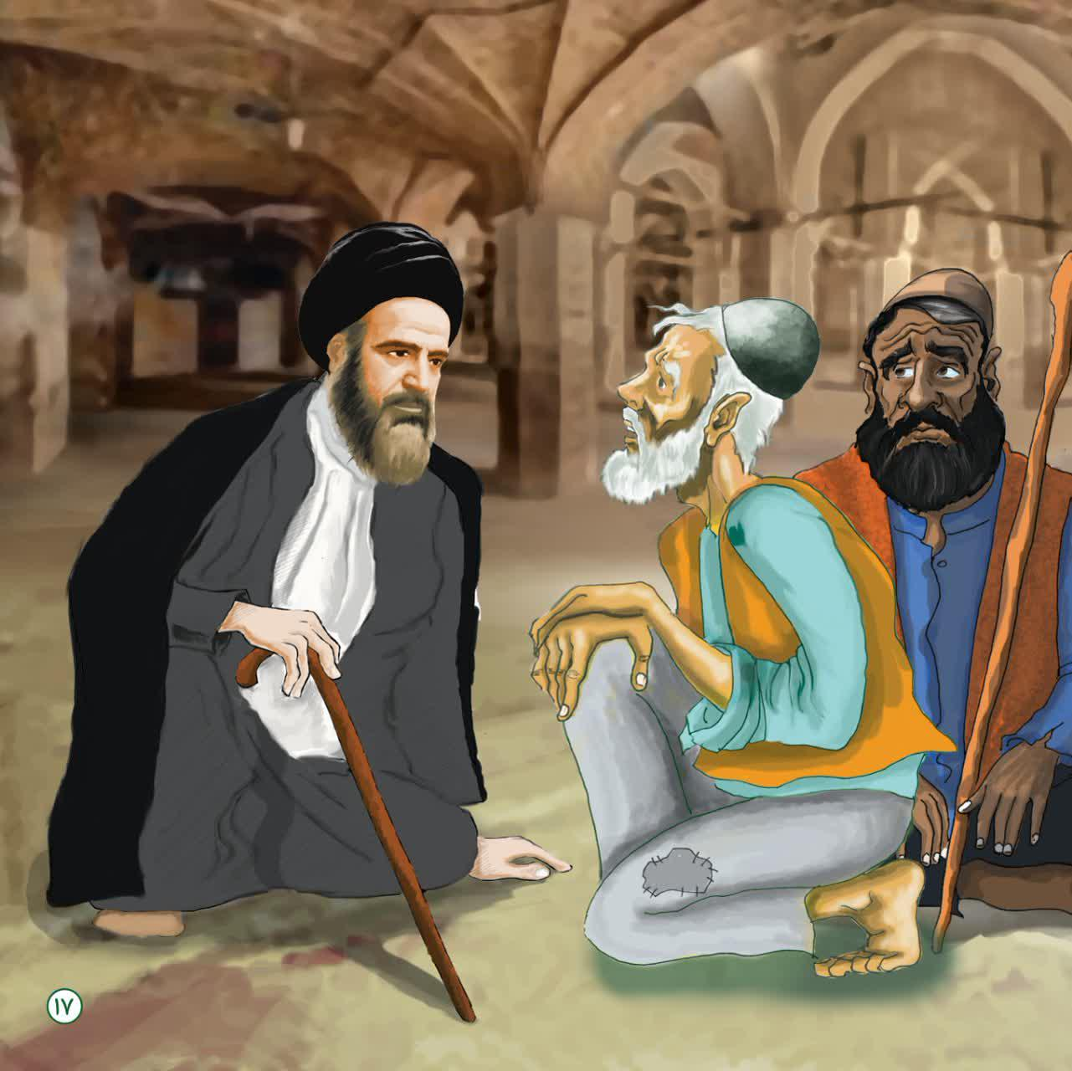
Three days passed. People were informed to come to the Grand Mosque for supplication and prayer. Everyone came, Sayyid included.
With his awe and greatness, he (seyed Abtahi) took off his black turban and started praying with his naked head and his constant burning and melting calling out to Imam Zaman and sheding tears.
He recited many times and people repeated it.
It was a strange time and people had a special passion. With that special burning and melting and always flowing tears, it created a commotion in the hearts of the people which was spectacular. Some fainted from crying so much. The mothers had gathered their little children in one place, and their cries and howls were accompanied by the burning of people's prayers.
Syed went to the pulpit in the middle of the Grand Mosque, under the sky.
He said: “God! I swear to you, I will not come down from this pulpit until you send rain on these people of Imam Zamani, although I am your small and sinful servant, but these simple-hearted and hard-working people are not guilty and have taken refuge in you.
God have mercy on us!”
With this mystery and needs and burning and melting, although it does not rain from the sky, but the sky of hearts roared with sighs and moans and thunder, and the eyes were cloudy.
Everyone was crying ...
Syed got up, and stood on the pulpit! He recounted his noble virtues, as if he were shaving his beard before God! He tilted his neck, said in an indescribable state: “God help us! Irrigate this land with the noble virtues of my grandfather Hussein!
O Rahim Sheikh Al-Kabir!”
image
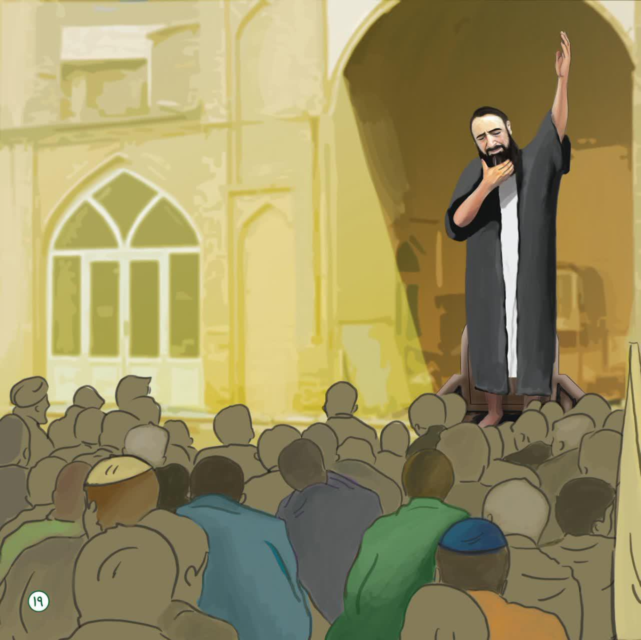
The sound of people crying makes the door and wall of the Eqlid of Imam Zaman Mosque shaking.
Next Seyed said: “May God have mercy on us with the bloody larynx of Ali Asghar Hussein ... and send the rain of your mercy on us!
O Raziq of the little child!”
With this secret and the needs and the burning and melting, not an hour passed that pieces of cloud were not found.
Then he said: “People! Let everyone put their hands on their heads and call the Imam of the Age in an emergency!”
O our Master or Sahib al-Zaman
الغوث الغوث الغوث
Help Help Help
Relief us, relief us, relief us
image


Shelter of Creation
He said: “O Imam Zaman! We have no one but you! You’re our only hope! You are the refuge of your creation!
You are the one who calms the tired heart and you are the one who heals the broken bone! Every distressed heart that is disappointed in the world calls you!
O Imam of Time! To the thirst of Abi Abdullah!I swear to Qamar Munir Bani Hashem! I swear to the sound of the children of Imam Hossien when they ask for water, send us some rain, show us your mercy!”
The cries of men and women, old and young, and children were raised with these words of Seyed.
The voice of Yabn al-Hassan of people shook the sky, and God's mercy boiled over, and for a moment all the people saw with their own eyes that the rain began to fall, and gradually the earth became wet.
The smell of scorched earth wafted in and out slowly.
image
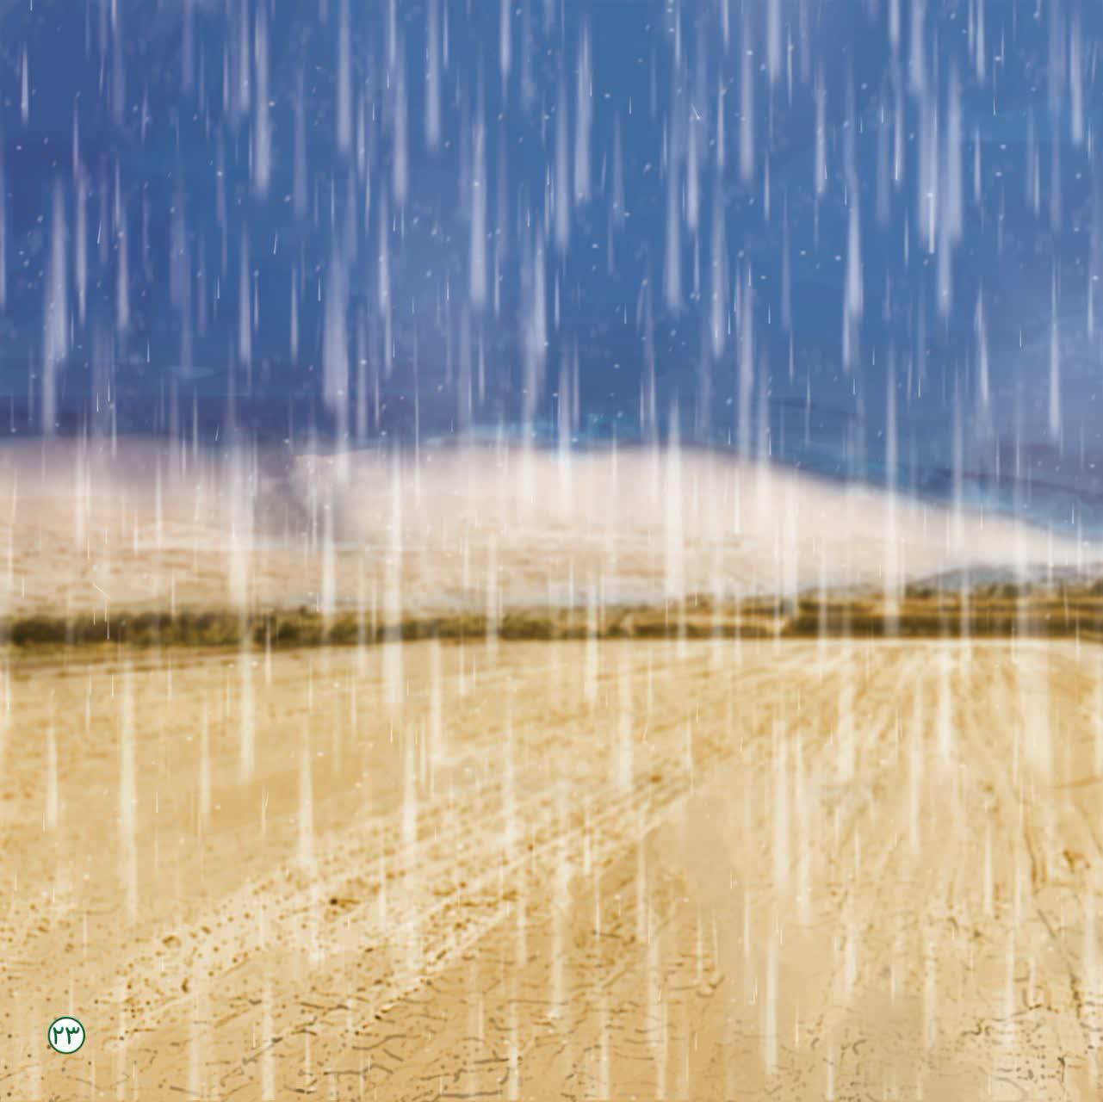
It was raining, but Syed was still on the pulpit, crying and not coming down from the pulpit.
It was as if the rain was another excuse for Syed!
Whenever the people insisted that Sayyid come down and he did not accept that it would not get wet from the rain, he said: “I swore that I will not come down until it rains heavily.”
The rain was pouring and Sayyid's clothes were completely wet. The rain water flooded in the mosque until the people hugged the pulpit and took it to the corner of Shabeston.
Syed had a strange mood! It was as if Sayyid's prayers had just begun with the arrival of the rain, he sat facing the qibla and the tone of his prayers changed.
People saw him cry more and more! Everyone heard what Sayyid al-Khattab was whispering to the Imam of the time:
“O Imam of Time! It rained and you did not come!
O rain of God's mercy! Step on our roasted hearts to calm down a bit.
Dear Fatima! Let our patience run out and the capital of our lives be lost.”
We saw Sayyid get up from Josh and start reciting the Ziyarat of Al-Yasin and shed tears.
image
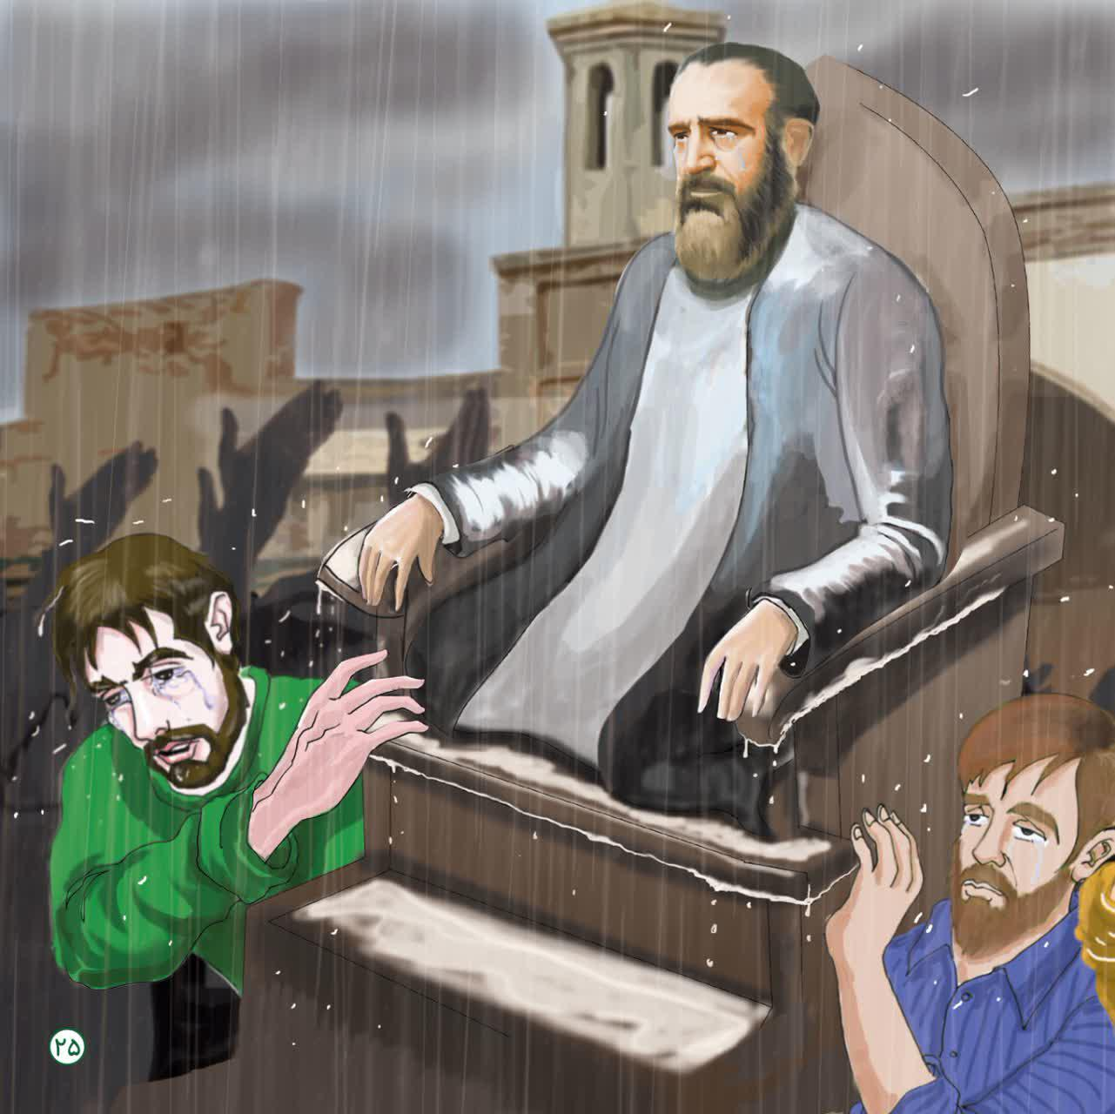
“Salam O Ahli Al-Yassin ...
My Lord! Imam Zaman! I know I left you alone ...
And in the hustle and bustle of the world, I lost my way.
I sought refuge in your mercy.
O Imam of Time!
The voice of the sinful child does not reach the sky;
So ask for forgiveness for us ... (we) pray for your reappearance!”
يَا أَبَانَا اسْتَغْفِرْ لَنَا ذُنُبَنَا, نِنَّا كُنَّا خَاطِئِينَ
image
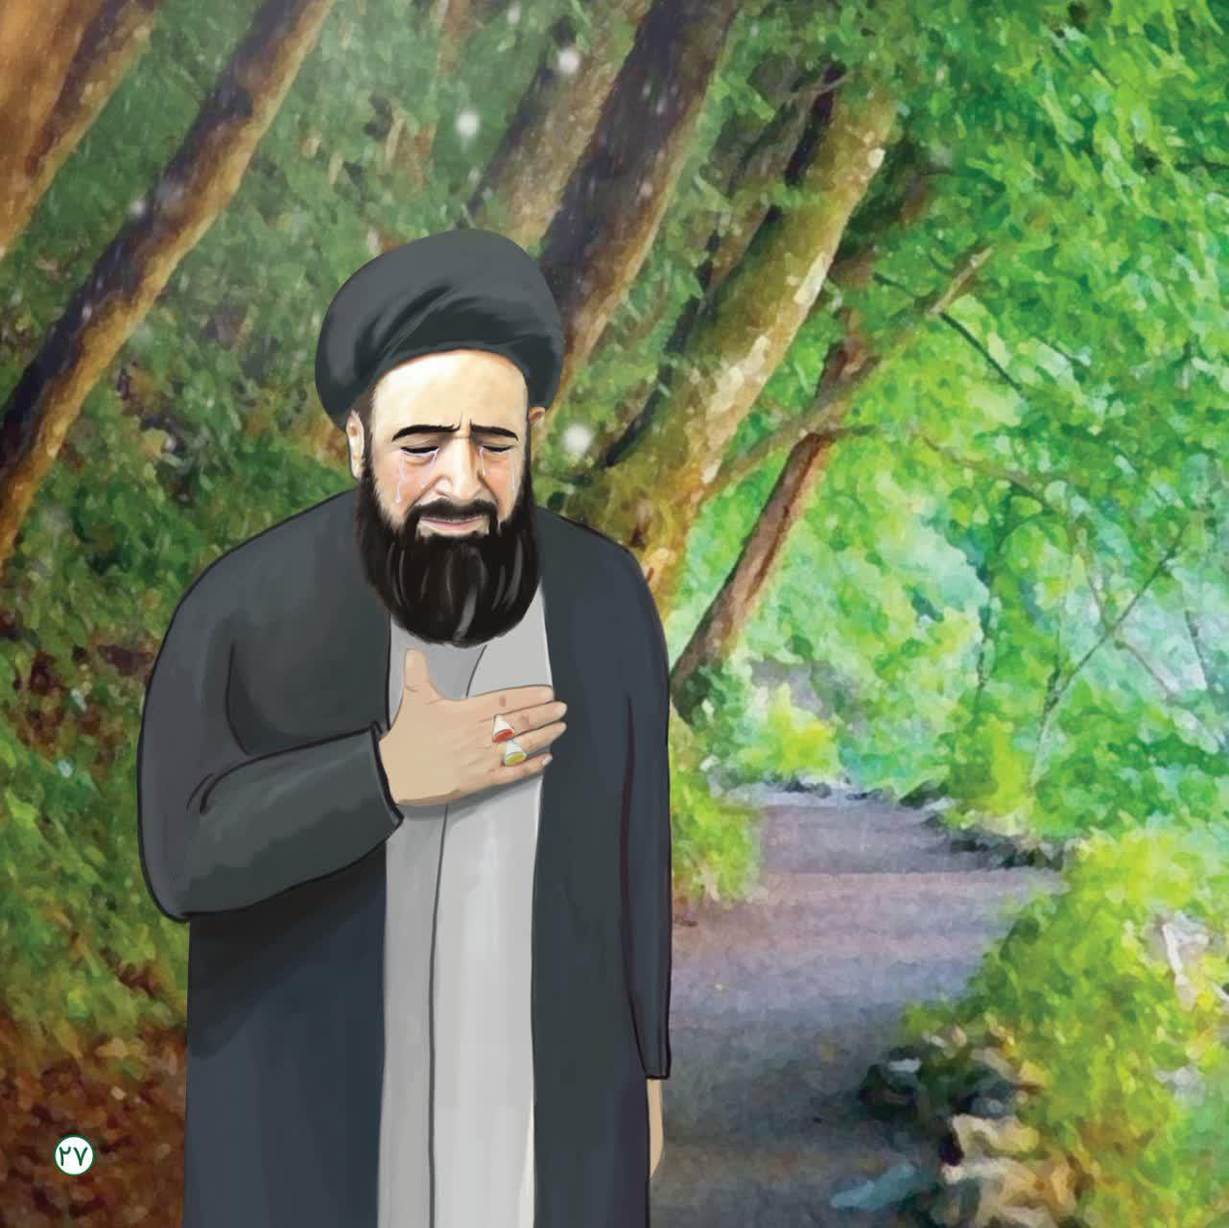
Agha Moallem was shedding tears and reciting Ayatollah Abtahi's prayers with Imam Zaman word for word when my cell phone rang. It was my mother.
I excused myself to from the teacher in order to answer her.
I answered and apologized to Agha Mohammadi again and told him we were going somewhere with the family.
I told the teacher to tell me the rest of the story and then I will go, he said: “No! You should return to your mother as soon as possible, God willing, in the future I will tell you more about this great Sayyid and what blessings were created by the blessings of Yabn al-Hassan, the son of Hazrat Zahra, in the region of Eqlid of Imam Zaman.”
I said goodbye to Agha Mohammadi and thanked him for his love today. The day was blessed ... and I headed home.
I was looking at the sky in the middle of the road and I thought, God, this sky is the same sky under which Ayatollah Abtahi prayed and his prayer was answered and it rained?!
At that time, there was neither meteorology nor technology .... With the tears and appeals of that beloved Imam Zaman, the clouds were fertilized and it rained like that.
Our parents and us breathed our last to be with Agha Abtahi and hoped for his prayers.
Now that this son of Hazrat Zahra has passed away, we, the children of Eqlid of Imam Zaman have become orphans.
God! You can answer my prayer and the children of Eqlid that the Imam of our time will come. I was impressed by Agha Abtahi's mournful prayers about how he begged for the reappearance of the Imam of the Age!
God! This is what I need. Do not let us down and bring near the appearance of Mehdi of Fatemeh!
According to Agha Moallem, if Imam Zaman comes, we have everything.
O God, hasten the faraj (reappearance) of our master.
image
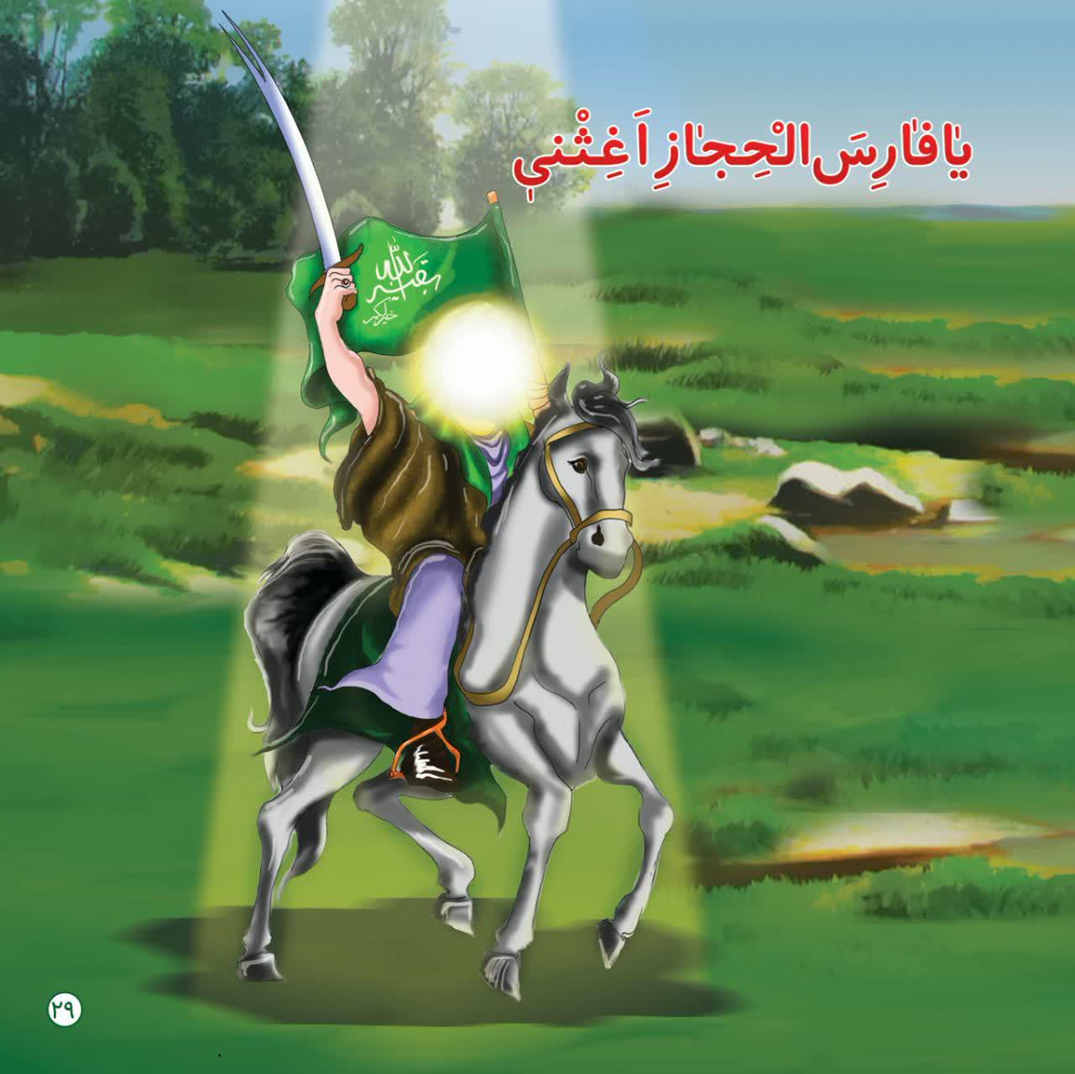
image

image
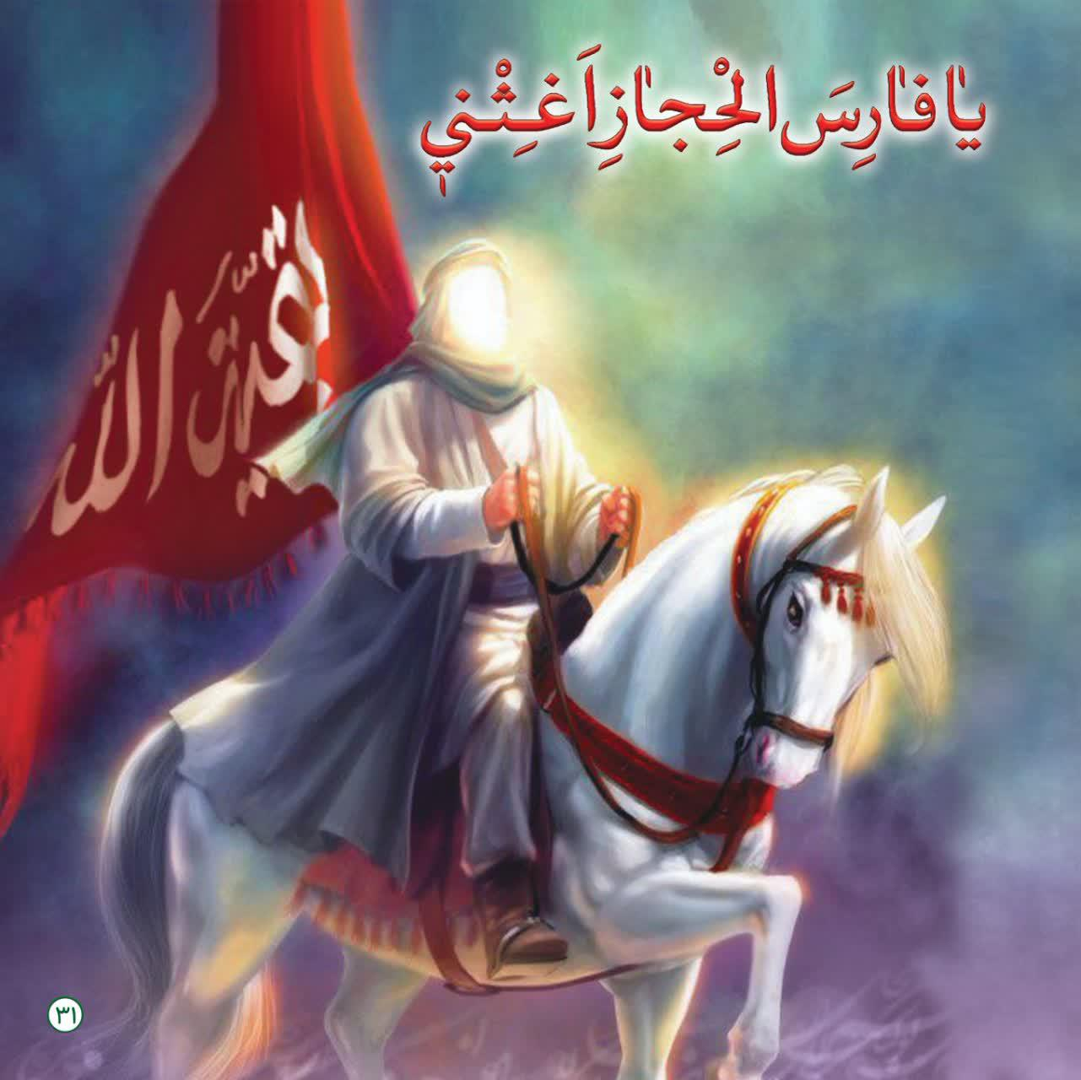

ghaemiyeh.com

